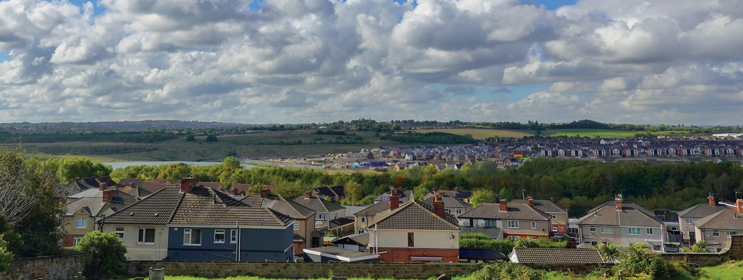


ROTHERHAM’S
HOUSING STRATEGY 2025-2030

www.rotherham.gov.uk/housing

ROTHERHAM’S HOUSING STRATEGY 2022-2025

TABLE OF CONTENTS
INTRODUCTION from the Cabinet Member for Housing | 3
THE VISION FOR HOUSING | 4
OUR APPROACH | 6
BACKGROUND TO THE STRATEGY | 7
ROTHERHAM PROFILE | 8
WIDER CONTEXT | 11
LINKS TO OTHER PLANS AND STRATEGIES | 14
CONSULTATION AND ENGAGEMENT | 16
PRIORITY 1 – Building high quality, sustainable and affordable new homes | 18
PRIORITY 2 – Improving the safety, quality and energy efficiency of existing homes | 23
PRIORITY 3 – Supporting our residents to live independently, including through prevention of homelessness | 28
PRIORITY4 – Ensuring that our neighbourhoods are safe, happy, and thriving | 33
CASE STUDIES | 37
GOVERNANCE, ASSURANCE AND DELIVERY | 46

By Councillor Linda Beresford, Cabinet Member for Housing

INTRODUCTION


Hello, and welcome to Rotherham Council’s Housing Strategy for 2025-30.
This is the document which shows what we’re trying to achieve in terms of housing in Rotherham. Our overarching aim is to ensure that people live in safe, well-maintained and thermally efficient homes and this aim is shared by our housing sector partners who have helped us develop this strategy.
Our strategy is reviewed for continuing relevance to make sure that we deliver what our residents need. Following extensive engagement, starting back in September 2024 at the Rotherham Show, I’m pleased to report that our priorities from the last edition remain the focus that people want us to concentrate on.
At some point during the lifetime of this edition of the strategy, we will undergo an inspection by the Regulator of Social Housing to determine how well we are carrying out our landlord functions and during the 2025-30 period we will complete a stock condition survey to capture a picture of the strength of our Council stock.
In 2018, we set ourselves the target of delivering 1,000 new Council homes, and we are on schedule to hit that number in Summer 2027, with 750 homes already delivered (at December 2025). Ensuring new homes are affordable for our residents is very important to us, we’ve set a target of making sure a minimum of 25% of new homes delivered are affordable.
Homelessness is a huge issue across the country and Rotherham is no exception, so we are placing an emphasis on providing more temporary accommodation and supporting people to get from presenting as homeless into a new home quicker.
Nationally, the Government has a strong focus on the importance of housing in people’s lives and more change is expected to come from them. The Government’s Five Step Plan sets out how they will work with the housing sector to increase the amount of social rented and affordable homes and improve the quality of existing social homes.
All in all, the period covered by this version of the strategy will be an exciting and challenging one for the Housing Sector. I believe Rotherham Council
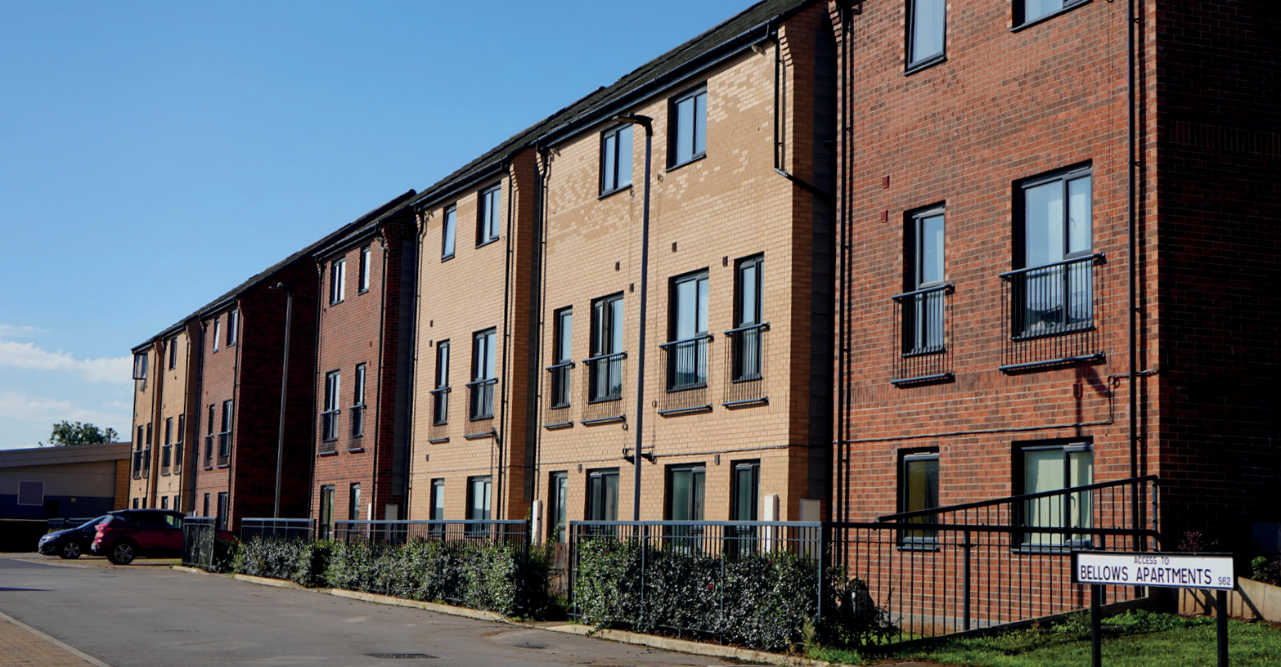
is ready to face the challenges head on to continue to provide top quality services for our residents.

Bellows Road, Rawmarsh

Rotherham’s 30-year Housing Strategy was published in December 2012 and sets out our long-term vision for housing in the borough until 2043.

The vision;
- People living in high quality homes.
- Rotherham Council being the best housing provider in the country.
- Reducing the gap between the most and least deprived neighbourhoods, so that everyone can live in safe, healthy and vibrant communities.
- Households living in energy efficient homes.
- A revitalised town centre with a new urban community.
The overall aims of the 30-year plan remain the same, however the Housing Strategy is refreshed periodically, to ensure it is up to date and addresses the most recent challenges and opportunities and references the latest statistical evidence, including consultation with our residents.

Priorities
For the period 2025-2030, the Housing Strategy will focus on four priorities with three key overarching aims for each priority:

Aims:
- We will work with partners to enable the delivery of new homes to meet local need.
- We will lead by example by building and acquiring hundreds of new Council homes.
- We will ensure new homes are high quality and sustainable.
PRIORITY 1:
Building high quality, sustainable and affordable new homes.

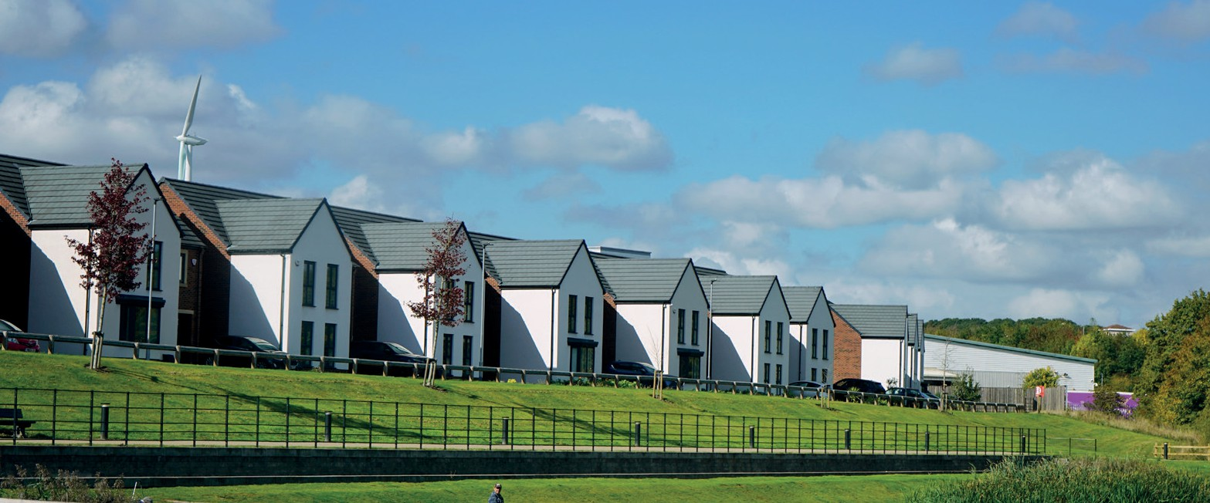

New homes in Waverley

Aims:
- We will work towards ensuring that no household is living in fuel poverty.
- We will ensure that our residents live in safe, decent, high-quality homes.
- We will work towards ensuring that all landlords, including the Council, operate to the highest standard
PRIORITY 2:
Improving the safety, quality and energy efficiency of our homes.

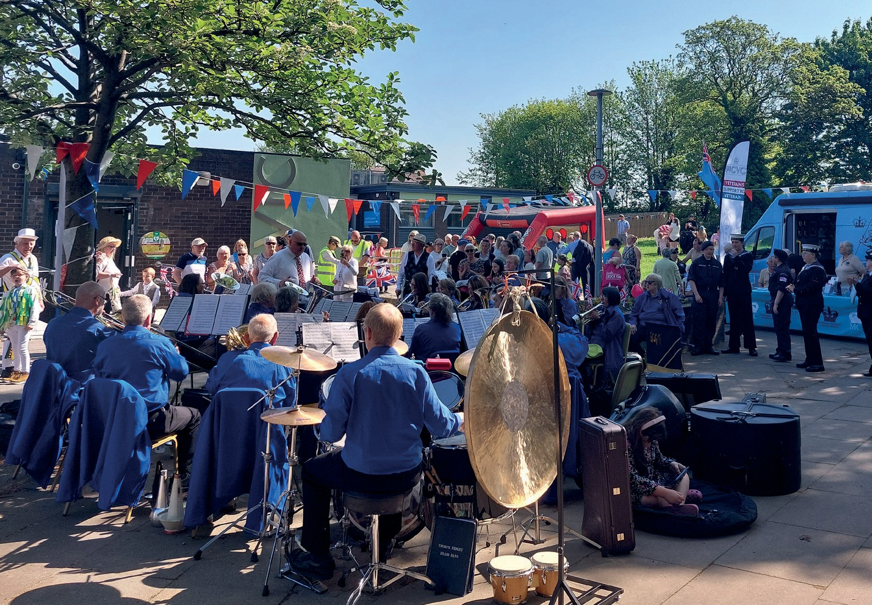

Swinton VE Day
Aims:
- We will work with partners to help our most vulnerable residents live independently.
- We will provide a range of housing to suit the needs of individual households.
- We will end rough sleeping in Rotherham and work to prevent our residents from becoming homeless.
PRIORITY 3:
Supporting our residents to live independently, including through prevention of homelessness.
Aims:
- We will bring empty homes back into use.
- We will invest in our communities to ensure they are inclusive and safe.
- We will ensure that new and improved homes support regeneration.
PRIORITY 4:
Ensuring that our neighbourhoods are safe, happy, and thriving.

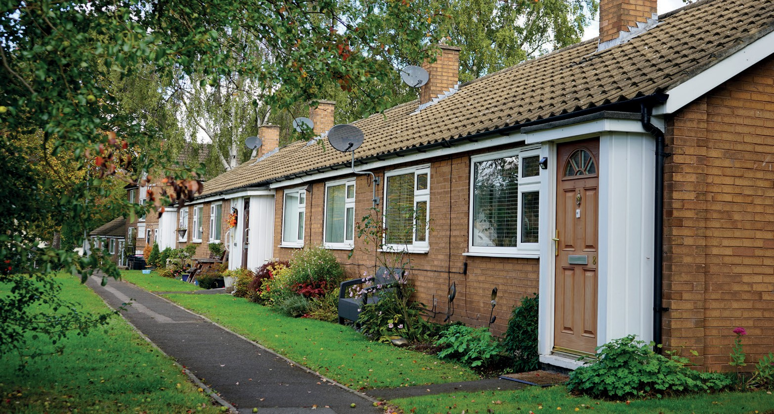

Council bungalows in Whiston

In delivering the four priorities outlined above, we will pursue three cross-cutting objectives: keeping our residents healthy and warm, playing our part to reduce carbon emissions, and reducing housing inequalities in and between our communities.

OUR APPROACH

Keeping our residents healthy and warm | Playing our part to reduce carbon emissions | Reduce inequalities in and between our communities
There is a clear and direct link between our health and our homes.  Implementing energy efficiencies including insulation to our homes will mean we are warmer and less likely to develop respiratory problems, as well as reducing the mental stress of high energy bills. Reducing hazards in the home will reduce the risk of ill health.  Building homes that are zero-carbon ready, with high energy performance means that new homes will be warmer and cheaper to run.  Adapting properties for residents who are growing older or have disabilities will enable them to live in their homes independently.  By building homes that are accessible, a greater range of homes will be available to meet the diverse needs of our residents.  Well-designed neighbourhoods support active travel, which has a range of health benefits. | It is estimated that around 20% of all carbon emissions are from our homes.  New homes have higher energy performance, and a new Future Homes Standard will see renewable, or electric energy sources replace non-renewable energy in new build homes. Building homes has  a significant carbon footprint, but this must be considered alongside the urgent need to house residents. Modern methods of construction can reduce the carbon footprint of housing development.  Decarbonising existing homes by improving insulation and retrofitting low-carbon heating technologies will also reduce carbon emissions.  Designing new estates and neighbourhoods that are well connected to services can help to promote active travel and therefore reduce dependence on cars. | The housing crisis does not impact everyone equally.  For example, some areas have higher numbers of privately rented homes that are smaller, older  and more likely to be in disrepair. This can lead to overcrowding and health issues, and make areas feel less safe. It can also disproportionately impact certain groups who are more likely to live in these areas, for example those on lower incomes.  Increasing the range, quality and energy efficiency of homes can address inequalities faced by older and disabled residents.  The cost-of-living crisis disproportionately affects residents on lower incomes, who spend more of their disposable income on housing. By reducing energy bills and housing costs, we can reduce financial pressure on residents.

Rotherham is one of four metropolitan boroughs in South Yorkshire. Around 70% of Rotherham is open countryside, but most residents live in urban areas. Our residents have access to several green spaces, woodlands and parks, including Clifton Park in the town centre. The town centre, a former hub of industrial iron and steel works, is undergoing regeneration, while

BACKGROUND TO THE STRATEGY
investments are also being made in Wath-Upon-Dearne and Dinnington town centres.
New homes are being built across Rotherham, including a new community at Waverley and significant recent development in areas such as Dalton, Dinnington, Ravenfield and Thorpe Hesley. Around 2,450 homes have been delivered over the last three years, averaging 816 homes per year. Around 29% of these have been affordable homes.
By working together, Rotherham has achieved much since our last priorities were set in the 2022-25 Housing Strategy. The Council has built, acquired or unlocked hundreds of new homes for social rent, private rent or home ownership.
The three mixed-tenure town centre housing sites, Wellgate Place, Millfold Rise and Westgate Riverside, were completed in 2023, creating 171 new homes for social rent, shared ownership and owner occupation, and setting the tone for housing-led regeneration of the town centre. The Council has added a further 341 Council homes and shared ownership homes to its housing stock between 2022-2025.
The Council has continued to work with partners to achieve its aims. We have enabled the development of 237 homes for rent and shared ownership in Thrybergh, owned and managed by Great Places and Sanctuary Housing Associations. Included in this scheme were 70 homes purpose-built to add
high quality homes to the private rented sector, owned and managed by Wise Living. The Council also worked with Action Housing and South Yorkshire Housing Association to acquire homes in the borough to provide temporary homes for rough sleepers.
The Council has explored new ways of delivering Council homes. The Small Site Homebuilding Initiative allows the Council to work with small local builders in Rotherham to build Council homes. The Council is also acquiring homes on the open market, aiming to purchase at least 100 by 2026.
Alongside meeting the need for new homes, the Council has continued to carry out improvements to existing homes over the past three years, including over 2,000 major adaptations to both Council homes and privately owned homes to help residents live independently. A major retrofit pilot in Maltby has improved the thermal efficiency of 130 Council homes. To improve the safety and management of the poorest quality housing in the private rented sector, the Council has continued to manage its selective licensing schemes
in areas around the borough and responded to 2,841 private sector housing enquiries, including disrepair, overcrowding and illegal evictions.


There are around 265,800 people living in Rotherham and around
122,000 dwellings.

For every Council home advertised for let, there are, on average 93 bids by residents on the housing register. This has increased by 80% since 2022.
93
7,000(approx) households are registered with the Council to find
a home to meet their needs, with 1,401 Council homes let each year.

64% households own their own home
 21% rent from the Council or
a housing association
15% rent from a private landlord


Almost a fifth of the population is over 65 years old (19.6%), and almost a fifth of the population is under 16 years old (18.9%).

22.3% of households live in a detached home
49.2% live in a semi-detached home
1,109 Council homes

18.2% live in a terraced home
10.3% live in a flat/apartment
have been sold under the Right to Buy scheme since 2018.

Our residents

ROTHERHAM PROFILE
There are around 265,800 people living in Rotherham. 64% of households own their own home (outright or with a mortgage), 21% rent from the Council or a housing association, and 15% rent from a private landlord.
Almost a fifth of the population is over 65 years old (19.6%), and almost a fifth of the population is under 16 years old (18.9%). The overall population size increased by 3.3%, or 8,500 people, between the 2011 and 2021 censuses. This increase is almost half the national rate of population increase (6.3%).
There are around 122,000 dwellings in Rotherham as of January 2025. 22.3% of households live in a detached home, 49.2% live in a semi-detached home, 18.2% live in a terraced home and 10.3% live in a flat/apartment.
7.5% live in a home with one bedroom, 24.7% with two bedrooms, 51.8% with three bedrooms and 16.1% with four or more bedrooms. 53.5% of people over 16 in Rotherham are employed. 42.2% are economically inactive, which includes 23.9% of people that are retired.
Some of our towns and villages are affluent areas, whereas some neighbourhoods are classed as deprived. 17.4% of households in Rotherham are classed as deprived in two of the following ways: education, employment, health or housing. To be deprived through housing, a household would
be living either without central heating and/or in overcrowded or shared accommodation.
Residents on low incomes continue to face higher-than-average inflation rates as they spend a higher proportion of their income on essentials, such as food. The cost of heating a home continues to increase, which has a direct effect on mental and physical health for those who cannot afford higher bills.
Neighbourhood level rates of fuel poverty range from 5.1% to 52.4%, with an average rate in Rotherham of 16.6%. Fuel poverty disproportionately affects single parent households and those over 60 years old. 2.6% of households in Rotherham are overcrowded. Overcrowding disproportionately affects families from BAME backgrounds. Conversely, around 40% of households live in homes with 2 or more bedrooms more than the household’s need (according to the Office for National Statistics official Bedroom Standard). Some of
these households are older residents in larger, unsuitable housing who may wish to downsize. 30% of the population of Rotherham live as single person households and this figure has increased by 1.5 percentage points over ten years. Almost 45% of single person households are over 65 years old.

In 2023-24, 1,444

Rotherham Minster
households were assessed as owed a homelessness prevention or relief duty by the Council. Of these, over 32% of households had dependent children. 42% were single men, more than double the number of single women. 10.8% had physical ill health or disability and 22.2% had mental health problems. 12.1% were in full time employment and 6.8% in part-time work.

Housing market
The pressure and demand on affordable housing increases year on year due to increasing house prices and rent levels, a shrinking number of Council homes, and the impact of the wider economy. Although the cost of living has suddenly spiked, the cost of homes has in fact been rising as a proportion of income for many years. This means we are facing a housing crisis deepened by the extra pressure of rising cost of living. In 1997, the average house price in Rotherham was 2.72 times that of annual earnings. By 2023 this ratio had almost doubled to 5.25.
The average house price in Rotherham is around £191,585 (the national average is £262,878) and for first-time buyers is £168,714. This had remained steady after the spike in interest rates after the mini-budget in 2022, however house prices have started to increase again.
The cost of privately rented properties is increasing at a high rate. The average cost to rent a private three-bedroomed property is £201 per week, a 51% increase over the last five years. This could be due to interest rates on buy-to-let mortgages increasing, whilst supply in the sector is shrinking.
Average house prices range from around £289,000 in the Thurcroft & Wickersley South electoral ward to £133,000 in Rawmarsh East Ward. House prices are generally higher and the market more buoyant in the south of the borough. In other areas the housing market is less viable and therefore private housing developers are less likely to invest. Intervention from the Council and public sector funding is important in these areas to secure regeneration.

Affordable housing
Renting from the Council or a housing association remains the only affordable option for many in Rotherham. Around 7,000 households are registered with the Council to find a home to meet their needs.
There are 20,076 Council homes for rent, in addition to this, there are 5,576 housing association homes offering affordable housing. Housing
associations offer 482 homes for residents who receive support or care to live as independently as possible, and 871 homes specifically for older people.
There were on average 1,401 Council homes let each year, over the last three years. For every Council home advertised for let, there are, on average 93 bids by residents on the housing register. This has increased by 80% since 2022. Affordable housing includes shared ownership homes, where the homeowner owns a percentage of a home and pays rent on the remaining share to the provider. These homes help residents that want to own their own home but might not have savings for a deposit. The Council owns 138 shared ownership properties and there are 392 housing association shared ownership homes in Rotherham.
The 2018 Strategic Housing Market Assessment (SHMA) concluded that there was a shortfall of affordable housing in Rotherham of 716 homes per year, for five years. In 2018, the Council set out to deliver 1,000 Council homes, and this will be achieved by Summer 2027. However, 1,109 Council homes have been sold under the Right to Buy scheme since 2018; and since its introduction in 1981, the Right to Buy Scheme has resulted in an overall 50% reduction in Council homes locally.

National and regional context
A new government was elected in July 2024, with a manifesto promising the delivery of 1.5 million new homes across the country over the course of the parliament. The Planning and Infrastructure Bill outlines a new approach, removing barriers to housebuilding, with the aim of delivering more homes at a faster rate. Housing targets are now mandatory, and the new National Planning Policy Framework increases the housing target significantly for Rotherham, to 1,111 new homes per year. This is around 200 homes per year more than current delivery, and much higher than the 500-650 figure identified in 2018 when the Council last conducted a needs assessment.
While the nationally set target is mandatory, a renewed local needs assessment is key to understanding what size, type and tenure of homes are required.
In November the government began to reform Right to Buy legislation, starting by reducing the maximum house price discount for tenants to
£24,000, a move that is expected to see the number of Right to Buy sales reduce over the long-term and help to stabilise the Council’s housing finances.
Rotherham is one of a number of local authority landlords campaigning for root and branch reform of the Housing Revenue Account – the financial system for council housing – so we are in a better position to invest in new and existing homes.
Housing will play an important part in the response to the climate crisis. The UK is committed to reaching net zero by 2050. This means that the total greenhouse gas emissions would be equal to the emissions removed from the atmosphere. Rotherham’s Climate Change Plan aims for the Council’s greenhouse gas emissions (excluding Council homes) to be net zero by 2030
and Rotherham-wide greenhouse gas emissions (including Council homes) to be net zero by 2040. The Government will be legislating to ensure all rented homes achieve at least EPC C by 2030.
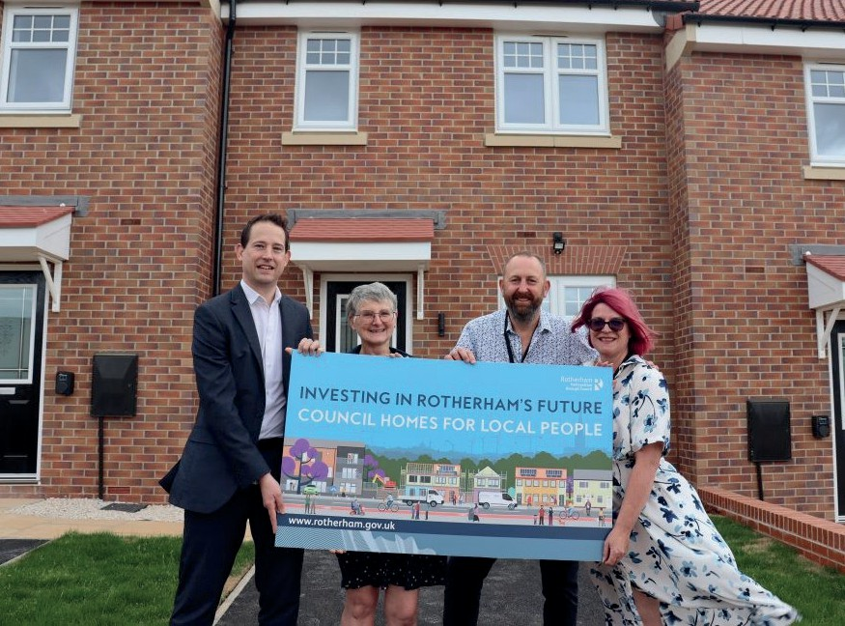
A raft of new regulations has been or will be introduced to improve quality, safety and standards in the social and private rented sectors, bringing many benefits to residents but also new challenges for landlords, including the Council, which will need to refocus investment on the homes we already own. Some of the key reforms are summarised over the following pages.

Shared ownership homes in Dinnington

Social housing

WIDER CONTEXT
A number of tragedies, including the Grenfell Tower fire in 2017, and the death of Awaab Ishak in Rochdale in 2020, have driven regulatory change across the social housing sector.
The four new or strengthened consumer standards are:
- Safety and Quality
- Transparency, Influence and Accountability
- Neighbourhoods and Communities
- Tenancy
They require social landlords to:
- ensure tenants are safe in their homes
- listen to tenants’ complaints and respond promptly to put things right
- be accountable to tenants and treat them with fairness and respect
- know more about the condition of every home and the needs of the people who live in them
- collect and use data effectively across a range of areas, including repairs.
To ensure the standards are being met, the Regulator of Social Housing will hold an inspection of the Council within the next four years. Social
landlords will also be subject to ‘Awaabs Law’, which provides legal minimum timescales to deal with certain types of hazards including damp and mould.

Supported housing
The Supported Housing Act 2023 aims to tackle poor quality supported housing and protect residents. The Act will introduce national standards for supported housing, local licensing schemes, a strategic planning requirement for local authorities to develop knowledge of supported housing supply and need, and a national expert advisory panel to monitor the sector.

Private landlords
The Renter’s Rights Bill was presented to Parliament in September 2024 and seeks to shift the balance of rights towards tenants, in the private rented sector. This includes abolishing ‘no-fault’ evictions and giving greater security to tenants, introducing a Decent Homes standard, extending Awaab’s Law
to the private rented sector and making it illegal for landlords to discriminate against tenants.

Building safety
The Building Safety Act 2022 overhauls existing building regulations and makes clear how residential buildings should be constructed, maintained and made safe. The Act protects leaseholders from historical building defects and creates three new bodies to provide effective oversight: the Building Safety Regulator, the National Regulator of Construction Products and the New Homes Ombudsman.
In its response to the Grenfell Tower Public Inquiry recommendations, the Government has signalled further reforms, including moving towards a single national regulator for construction and building safety.

The South Yorkshire Mayoral Combined Authority (SYMCA) is a formal partnership of Barnsley, Doncaster, Rotherham and Sheffield councils, alongside an elected Mayor, that shapes local policy and leads on decision-making in some areas. The South Yorkshire Housing Framework was published in January 2023 and outlines the vision for housing in South Yorkshire. The four key priorities are to increase energy efficiency and decarbonisation of existing homes, increase housing growth and affordable housing supply, improve the standard and quality of homes and to secure devolution of housing powers and funding.
Homes England is the government’s housing and regeneration agency and aims to accelerate the pace of house building across the country by working with regional partnerships, combined authorities and local authorities. The South Yorkshire Strategic Place Partnership is an agreement between Homes England and SYMCA to collaborate on overseeing housing development and regeneration, maximising funding, investment and support, and enhancing locally led housing growth and regeneration. Rotherham Council will play
an important role in this partnership to increase housing supply across the borough.

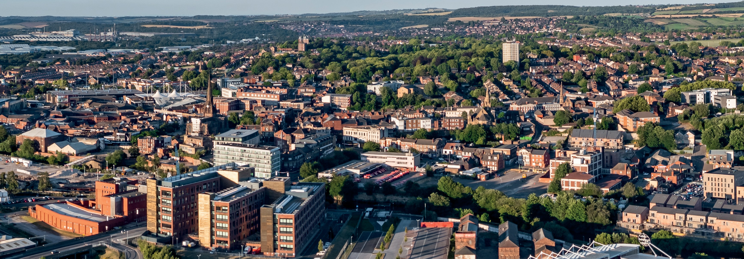

Rotherham town centre

LINKS TO OTHER PLANS AND STRATEGIES
Homelessness Prevention and Rough Sleeper Strategy The Housing Strategy has a direct link to preventing homelessness by outlining how we will deliver more homes and provide support for those
in most need. Our detailed plans to address homelessness are set out in a
separate Homelessness Prevention and Rough Sleeper Strategy.
Rotherham Plan 2025
Rotherham Together Partnership’s Rotherham Plan sets out how the Council will work with partners to deliver our ambitions for the borough. The Housing Strategy can help Rotherham become ‘a place to be proud of’, contribute to climate and environment goals, build stronger communities and improve health and wellbeing.
Council Plan 2025-2030: Forging Ahead
A new Council Plan was approved by Cabinet in May 2025. Housing has an important role to play in achieving all the strategic outcomes in the Council Plan and housing issues emerged as a key area of concern for residents during consultation.
Local Plan
The Local Plan is the Council’s statutory development plan for the borough, comprising the Core Strategy and Sites and Policies Document. Together these set out how much development should happen over the plan period from 2013 to 2028, where this should go and which sites are allocated to accommodate the new homes, jobs and shops the borough needs. The Local Plan also includes a suite of policies that the Council uses when determining planning applications. The Council is considering the implications of the recently revised National Planning Policy Framework (NPPF) and the much higher housing target for Rotherham, to decide on the future review of the Local Plan.
Health and Wellbeing Strategy
High quality, warm and affordable homes can play an important role in meeting the four aims of the Health and Wellbeing Strategy: all children get the best start in life and go on to achieve their potential, all Rotherham people enjoy the best possible mental health and wellbeing and have
a good quality of life, all Rotherham people live well for longer and all Rotherham people live in healthy, safe and resilient communities.
The Council’s Healthy Homes Plan aims to link together the current housing strategies with the health risks associated with various housing issues and outline an action plan to improve local housing intelligence, reduce fuel poverty and reduce housing related illnesses.

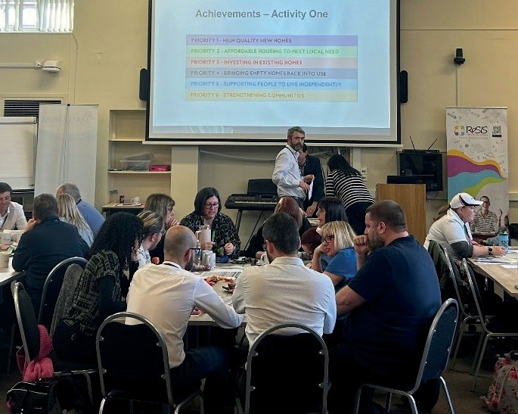

LINKS TO OTHER PLANS AND STRATEGIES

Consultation with Housing officers
Economic Growth Plan
The Housing Strategy will support the housing theme of the Economic Growth Plan, through direct delivery of new homes, by acting as an enabler to encourage development across all tenures to meet local housing need and creating an environment where the private sector has the confidence to invest.
Adult Care Strategy
The vision of this strategy is for residents to have access to the right information, services, support, and care to enable them to live well.
Good quality, accessible and well managed housing is central to meeting these aims.
Tenant Engagement Framework 2022-25
The framework aims to support tenant involvement in Council decision making, and involvement within neighbourhoods and communities. It also aims to ensure openness and allow tenants to scrutinise the Council’s performance. Consultation on a new Framework is ongoing.
Equality, Diversity and Inclusion Strategy
The EDI Strategy sets out the Council’s plans to deliver its equality objectives. The Regulator of Social Housing requires housing providers including the Council to understand and respond to the needs and characteristics of their tenants. Working with our communities and developing joint partnership approaches including Rother Fed and
the Housing Involvement Panel is key to engaging all groups in our communities.

Consultation and engagement

CONSULTATION AND ENGAGEMENT
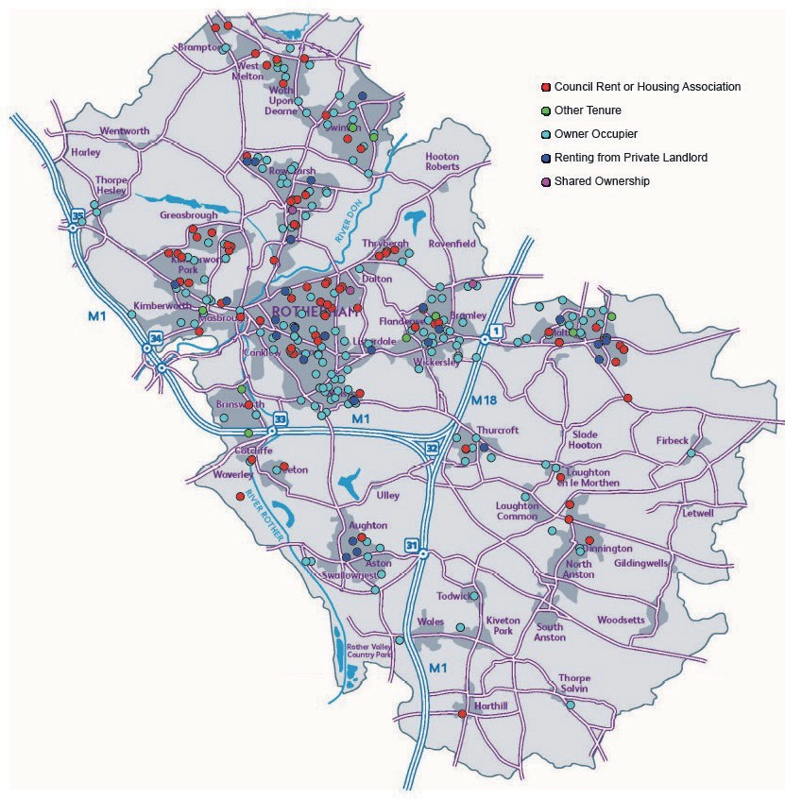
In August 2024, we launched a twelve-week engagement period to capture views about our residents’ housing priorities. We created an online survey and received 337 responses. A focus group was also held with residents to report on the results and share a first draft of this Strategy.
The map below shows the location of respondents to the online survey and the tenure of housing that they currently live in.

Which priority is most relevant to you?
Supporting people to live independently
22
Strengthening comm unities
13
Investing in existing homes
50
High quality new homes
22
Bringing empty properties back into use
71
Affordable housing to meet local need
85
0 10 20 30 40 50 60 70 80 90

We asked our residents what their most pressing housing issues are. Feedback centred around:

CONSULTATION AND ENGAGEMENT
- Concern about affordability in terms of buying homes, renting homes and for future generations.
- Creating more choice in housing options – including helping people to downsize, reducing overcrowding, creating homes for young families and addressing homelessness.
- Improvements to existing homes – including making homes more accessible and addressing disrepair issues, such as damp and mould.
- Working in the community to give people a voice and addressing anti-social behaviour.
“Help older, single people to move to smaller properties to allow families to have bigger houses.”
“Provide help with buying a house, renting is even more expensive.”
“Build affordable housing but also make use of empty retail buildings and empty residential property.”
“Bring in some sort of scheme to take homes from the private sector into the public sector – voluntarily by purchasing them from estate agents.”
“Development of mixed communities in new estates ie shared ownership and private owned.”
We have also sought residents’ views through events such as the Rotherham Show in 2024 and our annual Tenant Open Day.
We have engaged a wide range of stakeholders and partners to shape a draft of the Strategy, including members of our Health and Wellbeing Board, Economic Growth Board, Housing Involvement Panel and the Strategic Housing Forum.
In addition, of the 254 residents who engaged with the consultation to inform the new Council Plan, 5% commented that more affordable housing was needed. 187 respondents agreed that ‘Tackling homelessness’ was more important than ‘Allowing fewer new homes to be built’ (56 respondents).
Amongst focus groups, ‘providing high quality, affordable homes and tackling homelessness’ was one of the most discussed subjects.
Taking into account all of this feedback, alongside housing data and intelligence and the national policy context, we propose to set four priorities for the new Housing Strategy:
Priority 1 – Building high quality, sustainable and affordable new homes.
Priority 2 – Improving the safety, quality and energy efficiency of existing homes.
Priority 3 – Supporting our residents to live independently, including through prevention of homelessness.

Priority 4 – Ensuring that our neighbourhoods are safe, happy, and thriving.


The Government’s new Housing Delivery target for Rotherham is
2,450
new homes built in
over past three yea

1,111 HOMES
PER YEAR

29% of this is affordable housing for rent or shared ownership delivered by the Council or other
registered providers of social housing in Rotherham.

Rotherham rs.


Average house price

5.25 TIMES ANNUAL EARNINGS
£191,585 is the average house price in Rotherham (the national average is
£262,878) and for first-time buyers is around £168,714.

Building high quality, sustainable and affordable housing is essential to help meet current housing needs and the housing needs of future generations of residents. By building more homes, we will be able to provide a wider choice of housing for our residents. The market needs
to continue to deliver new homes for owner occupancy including affordable home ownership, such as shared ownership, which are homes with prices below the market level and are important to help residents who want to get on the property ladder.
A new Future Homes Standard is likely to be introduced in 2025 which will require all new homes to meet design requirements, including the installation of energy efficiency measures and low carbon heating, such as air source heat pumps in place of gas boilers. The Council has already started to deliver zero-carbon ready homes for social rent at various small sites in East Herringthorpe and will continue to do so on planned sites around the borough. These new homes will help to keep our tenants warm and reduce energy costs.

Over the past three years we have:
- Delivered a total of 2,450 new homes across the borough and when the Housing Delivery Test was last measured in 2023, achieved 173% of the government’s target for new homes in Rotherham.
- Through the Council’s Housing Delivery Programme, delivered 304 Council homes and 37 shared ownership homes. The three mixed-tenure town centre housing sites, Wellgate Place, Millfold Rise and Westgate Riverside, were completed in 2023, creating 171 new homes for social rent, shared ownership and owner occupation. Added to previous years, the Council has delivered a total of 674 homes for rent and shared ownership since 2018.
- Published the Housing Acquisitions Policy with approval to acquire 100 existing homes for social rent. We have acquired 87 as of September 2025.
- Directly delivered 42 homes for open market sale and enabled the delivery of 404 homes by other developers, including:
- Enabling the Whinney Hill & Chesterhill Avenue development, which created 237 new homes for affordable rent, shared ownership and private rent in Thrybergh built through Equans and owned and managed by Great Places, Sanctuary Housing and Wise Living.
- Delivered ten green, zero-carbon ready homes on Council sites across East Herringthorpe. These homes include one- and two-bedroomed homes, two-bedroomed bungalows and a four-bedroomed disabled persons bungalow.
- Captured and analysed customer feedback to understand the wider impact of new homes so customers views can help shape future development activity.
- Worked with Homes England and SYMCA to develop a pipeline of development sites across the borough; and published a consultation on a new Strategic Planning Document for Bassingthorpe Farm

In June 2018, the Council’s Local Plan was formally adopted, replacing the Unitary Development Plan. The Rotherham Sites and Policies Local Plan sets out policies and identifies specific uses for potential development sites across the borough. Public consultation on a partial update to the Core Strategy in 2024 sought to ensure that the Affordable Housing Policy remains deliverable without affecting viability of schemes.
Rotherham’s Affordable Housing Supplementary Planning Document (SPD) states that at least 25% of any large housing development should be affordable housing. Due to the Council’s housing development programme and house building by our housing association partners, the percentage of affordable homes delivered annually is sometimes higher than 25%.
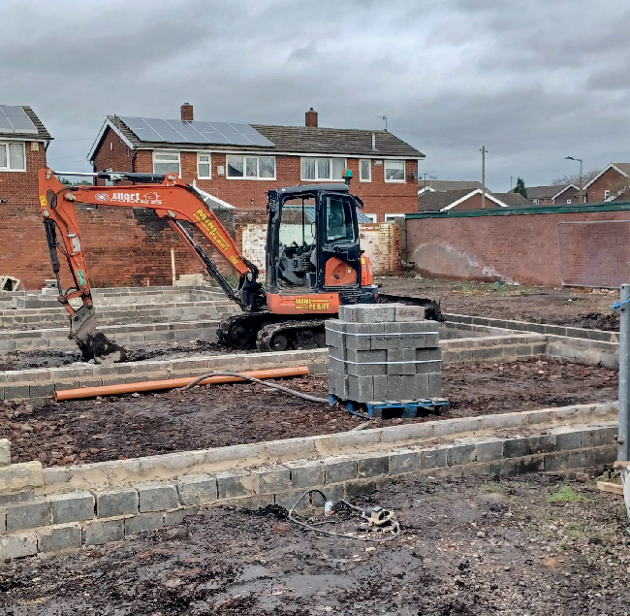
The Council will play an important role

Construction of Council homes at Parkgate
in bringing forward key strategic sites for housing development and creating new
communities, including around 2,400 new homes, a local centre and primary school at Bassingthorpe Farm, north of the town centre.
Public consultation has concluded and the
Bassingthorpe Farm SPD has been adopted.

Affordable homes
The term ‘Affordable housing’ is used regularly in discussion and debate about housing need. Residents have told us that they would like more affordable housing in Rotherham in terms of lower rents and house prices. However, ‘affordable housing’ is defined by the National Planning Policy Framework as
“housing for sale or rent, for those whose needs are not met by the market (including housing that provides
a subsidised route to home ownership and/or is for essential local workers).”
Under this definition, all Council and Housing Association rented homes are classed as ‘affordable’ and rents should be set at least 20% below the average private rented sector rent levels in the area.
Shared ownership homes, where you can buy a share of the property and pay rent to a landlord on the rest, are also ‘affordable’. Other options to buy a property at a discounted rate include First Homes and Discounted Market sale.

The Council’s housing delivery programme has delivered 709 homes for Council rent, affordable rent and shared ownership, as well as 125 homes for open market sale since 2018. The Council is committed to reach the 1,000 Council homes milestone by the Summer of 2027. To do this, we will build and acquire a range of homes required to meet the needs of our residents throughout the borough, through our four delivery routes.
  - Council build – the Council will use brownfield sites, such as low-demand garage sites to provide new high-quality homes in existing communities. These include larger family homes, apartments for older people, smaller homes and flats for single people and couples, and accessible bungalows for residents with disabilities.
  - Section 106 acquisitions through the Planning system – Any development of 15 or more units is required to deliver 25% affordable housing. The Council is committed to purchasing homes from developers at sites around the borough.
  - Small Site Homebuilding Initiative – the Council invites local small and medium enterprise developers to approach us with opportunities to purchase homes they build.
  - Acquiring existing homes – including those formally owned by the Council and subsequently sold under the Right to Buy.
It is important that we work together with partners including housing associations, Homes England and SYMCA to deliver affordable housing, access the required funding to build these homes and create a pipeline of delivery. Purpose-built private-rent homes are also important and will help to meet the need of those that cannot afford to buy.
Our residents have told us that it is important to use previously developed land, or ‘brownfield land’, to help create new homes. The Council has been proactive in this, by selling unused sites to housing developers, developing underused Council sites for Council homes and enabling sites to come forward by liaising with developers to remove barriers to development.
Changing tenure of existing homes can create more affordable housing and reduce numbers on the housing register. In 2023, the Council’s Housing
Acquisitions Policy was approved, which allows the Council to purchase homes on the open market. 87 homes have been purchased and converted to social housing since March 2024, with improvements made to all properties before they are let to tenants. The Council will continue to acquire homes between 2025 and 2030 by buying back former Council homes sold through the Right to Buy scheme, properties that are empty and any other opportunities that meet current social housing need available on the open market.

Our aims:
- We will work with partners to enable the delivery of new homes to meet local need.
- We will lead by example by building and acquiring hundreds of new Council homes.
- We will ensure new homes are high quality and sustainable.

How we will measure success:
  - Increase the number of new homes built in the borough.
  - Ensure a minimum 25% of new homes are affordable housing.
  - Increase the number of Council homes available, including through new build and acquisitions.
  - Ensure all Council new build and acquisitions are a minimum EPC C when let.

Over the next five years, we will:
  - Provide a high quality, efficient planning service to help accelerate delivery, including pre-application advice for housing developments and working with housing developers and builders to enable key strategic housing sites identified in the Local Plan to meet housing targets.
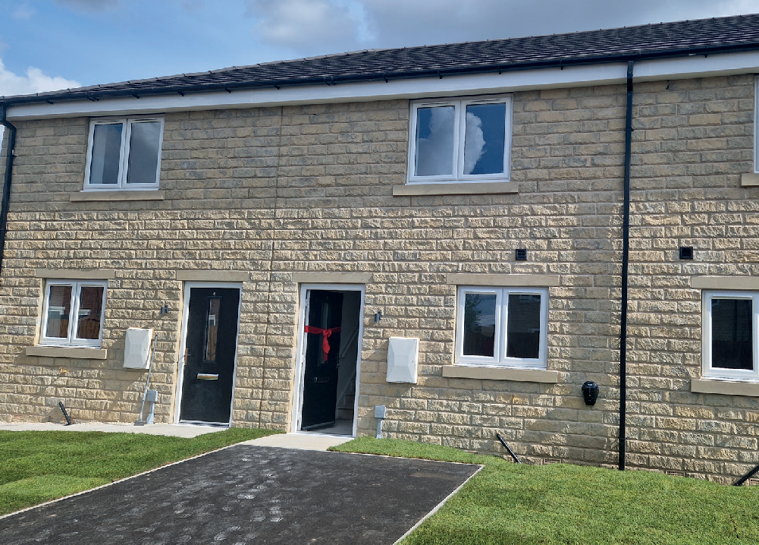
  - Continue to diversify the housing offer in the borough, including affordable home ownership options such as shared ownership, more joint working with SMEs and housing associations, supported by partnership working with SYMCA and Homes England to maximise funding opportunities for housing schemes.

Energy efficiency improvements in Maltby
  - Adopt the Bassingthorpe Farm Supplementary Planning Document and work with partners to shape delivery of this and other key strategic housing sites.
  - Deliver more Council and affordable homes through our Council build, acquisitions and small sites homebuilding initiative programmes on sites across the borough, and through our work to enable affordable housing with partners. We will achieve our 1,000 Council homes target by summer 2027 and build a pipeline of future affordable housing projects.
  - Meet and where possible, exceed minimum nationally described space standards when building new Council homes, and build new homes with renewable energy systems to ensure that they are zero carbon ready to meet the Future Homes Standard. We will also ensure all Council acquisitions are a minimum of EPC rating C.
  - Use our Place and Quality Panel to ensure schemes are delivered with input from cross-Council services and that we learn from outcomes of recent delivery.

16.6% of households in Rotherham live in fuel poverty.
Nationally, over the last 10 years, the proportion of homes in the highest energy efficiency bands A to C increased (19% to 48%). Homes in the social rented sector saw the largest rise (36% to 70%) (English Housing Survey 2023).

Currently, 60.68% of Council homes are band C or above, and 99.72% are band D or
G
F
E
D
A B C
above. All rented homes need to achieve Energy Efficiency Rating of C or above by 2030.

The Private Rented Sector makes up
15% of homes in Rotherham, in Selective Licensing areas this is up to 36%.
71% of landlords in Selective Licensing areas are responsible for only one property. 6% of landlords have 5 or more properties.
Levels of category 1 hazards across the borough vary from 21.75% of private rented stock
in Rotherham East to 10.79%
in Bramley and Ravenfield.

Net Zero carbon
There are around 122,000 homes in Rotherham. Over two-thirds of these homes were built over 60 years ago. Older homes are more likely to be less energy-efficient than newer homes so there is a huge task to meet local and national decarbonisation targets. Retrofitting insulation, reducing the reliance on non-renewable energy and introducing smart technology are ways to improve energy efficiency, lower the costs of heating homes and keep residents warmer.
The condition of our homes has a direct impact on health. Hazards such as excess cold or heat, and damp and mould can cause serious respiratory illness. Ensuring homes are properly insulated is key to keeping our residents warm. Poor housing conditions cost the NHS around £1.4bn per year. Teachers are unable to close attainment gaps for children who turn up at school living in damp or temporary homes. Worry about increasing energy costs can have an impact on the mental health of our residents.
The government has set a legally binding target to reduce the UK’s net emissions by 100% by 2050 compared with 1990 levels. This is known as the ‘net zero target’.
In 2022, emissions from residential buildings accounted for 20% of greenhouse gas emissions in the UK. The Climate Change Committee (CCC), the government’s advisory body, said the
UK will not meet its emissions targets “without near complete decarbonisation of the housing stock”.
Emissions from residential buildings come mainly from fuel combustion (the burning of oil and gas for heating and hot water) and electricity use. Homes can be decarbonised by installing low-carbon heating systems (such as heat pumps), fitting insulation to improve their energy efficiency and installing renewable energy systems (such as solar panels). These measures also bring benefits for residents, including warmer homes and cheaper bills.
16.6% of Rotherham households live in Fuel Poverty when measured by the government’s Low Income Low Energy Efficiency (LILEE) definition, where households are considered fuel poor if they are living in a property with an energy efficiency rating of D or below AND when they spend the required amount to heat their home, they are left with a residual income below the official poverty line. With rising energy costs, an increasing number of residents are likely to struggle to heat their homes.
It is important that all landlords operating in Rotherham, including the Council, ensure that their properties are managed to a high standard. The Council will ensure that
all standards in the Social Housing Regulation Act 2024 will be met and that we are ready for an inspection, so that our tenants can have the confidence they are safe in their homes and treated with respect and fairness. The Council is investing heavily in improving its own housing stock and dealing with hazards such as damp and mould, supported by a stock condition survey of all Council homes that commenced in 2025. Currently not all of our Council homes meet the Decent Homes Standard.

Over the past three years we have: The Council is committed to ensuring that all Council homes have an Energy Performance Certificate (EPC) rating

- Completed a major Social Housing Decarbonisation Pilot. This has improved the thermal efficiency of 130 Council homes in Maltby, 125 of which now have an EPC rating of
C. 1,363 projects have been delivered to private homes through ECO4/Great British Insulation Scheme-Flex programmes, totalling almost £9m worth of measures.
- Published a new multi-tenure Damp, Mould and Condensation Policy and invested heavily in preventing and repairing damp and mould in Council homes. This has supported an improvement in performance from 28% of Council home inspections undertaken within 10 working days in April 2023 to 99.8% in January 2025. The Council has also responded to 150 damp and mould enquiries from tenants living in the private rented sector and held sessions with over 250 residents to provide advice on damp and mould.
- Made a range of investments in our Council homes, including:
  - £12.3m on 4958 boiler replacements
  - £4.6m on thermal improvements to 644 properties
  - £17.3m on roof and roof line replacement works to over 1339 properties
  - £762k on window and door replacements to 711 properties
  - £1.4m on electrical upgrade works to 404 properties
  - £1.7m refurbishing 31 properties at Catcliffe following flood damage
  - £1.2m replacing 823 fire doors.
- Issued 235 licenses to landlords in Selective Licensing areas, in addition to the 2,088 since the commencement of the scheme in 2020; and responded to 2,841 private sector housing enquiries, including in relation to disrepair, overcrowding and illegal eviction.
C by 2030, thus ensuring that no tenant is living in fuel poverty. To do this, significant investment is needed, and opportunities for government funding will be prioritised.
Nationally, 14.9% of social rent tenants live in fuel poverty, whereas 24.1% of tenants that rent from private landlords live in fuel poverty. Single parents and households renting from private landlords are the groups most likely to be living in fuel poverty.
In Rotherham, the private-rented sector increased in size between 2010 and 2016, although has now shrunk slightly to form 15.3% of housing in the borough. This is around 4% below regional and national levels. The sector provides an important role and renting from private landlords is often the only option for residents facing affordability issues alongside the high number of households on the Council’s housing register.
The Council is committed to supporting and promoting private landlords who provide quality, well managed, and affordable housing. However, there are concerns that standards within the sector are falling below the minimum expected under the Housing Act 2004. Poor housing conditions, including damp and mould and excess cold, as well as physical safety risks to private tenants need to be addressed. The Council can use tools including civil penalties

and banning orders on landlords who fail to address poor housing conditions and enforce action against hazards in privately owned and rented homes.
The Housing Act 2004 introduced selective licensing to give local authorities a tool to help tackle problems in the private rented sector, including:
- low housing demand
- a significant and persistent problem caused by anti-social behaviour
- poor housing conditions
- high levels of migration
- high level of deprivation
- high levels of crime
Local authorities can designate an area for selective licensing for five years. Subject to limited exemptions, a valid licence must be held by the appropriate responsible person in respect of all privately rented properties in such a designated area, typically the landlord or managing agent.
Licences contain conditions with which the applicant must comply over the life of the designation. Local authorities inspect properties in the area and enforce compliance with the conditions of the licence. The licence requires payment of a fee, one part of which covers processing of the application, and the remainder supports the associated enforcement scheme.
Overcrowding can be an issue in privately rented homes and can affect the health and safety of families. The Council can carry out assessments on reported overcrowding, which will then, if assessed as overcrowded, enable the family to be a priority case on the housing register.
Selective Licensing is currently in use in areas of the borough and being considered for other areas, as a means of ensuring private sector landlords manage their properties appropriately. The Council recognises that Selective Licensing is an effective tool for improving the quality of private rented housing and will make use of the appropriate powers to ensure improvements are made for Rotherham’s private rented sector tenants. The Council will also make use of any new powers provided in the Renter’s Rights Act.

Selective Licensing

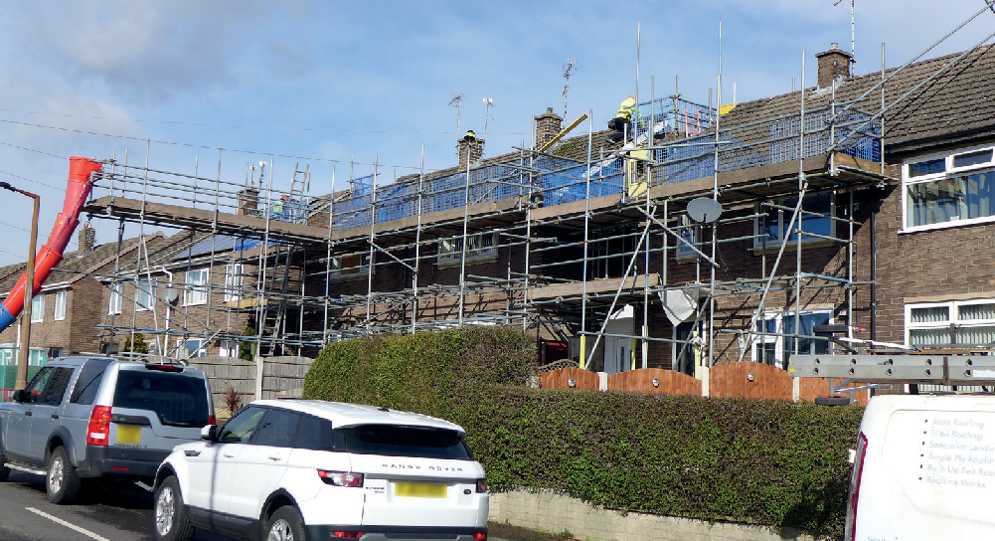

Improvements to Council homes in Maltby

Our Community Energy Team enable energy efficiency grants for private sector households, especially our most vulnerable homeowners and private-rent residents and/or for homes with the poorest EPC ratings. To update intelligence about the condition of private sector housing, SYMCA are intending to commission a stock condition survey of all private homes in South Yorkshire.

Our aims:
- We will work towards ensuring that no household is living in fuel poverty.
- We will ensure that our residents live in safe, decent, high-quality homes.
- We will work towards ensuring that all landlords, including the Council, operate to the highest standard

How we will measure success:
- Increasing the percentage of satisfied tenants in all of the Regulator of Social Housing’s Tenant Satisfaction Measures.
- Increasing the proportion of our Council homes that meet the Decent Homes Standard and continue to improve our repairs and health and safety compliance performance.
- Increasing the number of private sector landlord actions addressing Category 1 and 2 hazards following Council intervention.
- Reducing the percentage of households living in (Low Income Low Energy Efficiency) fuel poverty in Rotherham.
- Increasing energy efficiency in existing homes, including ensuring all Council homes achieve an EPC certificate minimum rating C by 2030.

Over the next five years, we will:
- Meet or exceed minimum council housing standards to ensure our tenants are safe in their homes. We will focus on improving our
performance against the Decent Homes Standard; ensuring all repairs, risk assessments, inspections and safety checks are carried out to target timescales; and improving how we manage our homes and work with our tenants to meet the consumer standards. This will be underpinned by our stock condition survey and a £37m expansion in our housing improvements capital programme.
- Continue to provide a range of support to address fuel poverty and improve energy efficiency. Our energy crisis support scheme will support qualifying residents in fuel poverty, and our Healthy Homes Plan will provide help and advice to residents to increase energy efficiency
in their homes, supported by ECO4 and ECO5 grants for our most vulnerable residents and/or homes with the lowest energy efficiency.
- Develop our council housing decarbonisation plan, aiming to meet legal requirements to achieve EPC C by 2030, and then a roadmap to net zero emissions. We will maximise opportunities to invest in the borough by bidding for funding that becomes available through Department for Energy Security and Net Zero.
- Hold landlords accountable for the condition and management of their properties and conclude the review into Selective Licensing. We will also implement new powers granted by the Renters Rights Act.

Life expectancy in Rotherham has decreased over the past 10 years by 11.4 months for a male at birth and 14.3 months for females at birth. Healthy life expectancy in Rotherham is significantly lower than the national average at 56.5 for females (compared to 63.9) and
58.7 for males (compared to 63.1).

19% of pupils say where they live as a major barrier to school
attendance – up from 11% (School Home Support survey 2023).

1/5 presenting as homeless
to the Council are from the Private Rented Sector (PRS).
As of 1 April 2025, 217 people on the housing register were in the highest




priority banding. 390 people have
a homelessness duty. 818 need to
move on medical grounds.

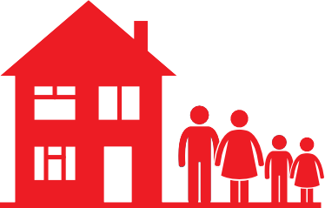
Where homelessness has been prevented, in 23/24, 61% went to social rent, 25% PRS, 10.6% family or friends.



Over half (54%) of the 301 main homelessness duty decisions made by the Council in 2023-24
were households with children.

Our homes are an important source of health and wellbeing. All our residents should have access to homes that meet their individual needs. Understanding the housing needs of our residents and providing them with a choice of housing and support is key to ensuring our residents live healthy, independent lives.
It is important that young people in Rotherham can leave their family home when they are ready and live independently. There needs to be a choice of housing for younger people, who are more likely to be single, or who have young families. Residents told us that they were concerned about the housing options for younger people, and that we need to provide options for rent and for home ownership.
Some of our younger residents need support and advice when accessing housing. This can include providing financial advice to avoid debt and support on how to sustain tenancies. Pre-tenancy advice is key to ensure that our tenants are living in the right property in terms of affordability and suitability to their housing needs. For residents with care and support needs who have a disability, are neurodiverse or experience mental ill health, short- or long-term support with housing may be required.
Collaborative working between Council services and other organisations is key to ensuring that our residents can live independently. Our Adult Care Strategy’s person-centred approach means that support is tailored to the individual and used to empower people to make choices for themselves. Our occupational therapists work with Adult Care, Housing Options and Housing Development teams to ensure specialist housing needs are understood and met through adaptations to current homes and design for new build homes. Children and Young People’s Services work closely with Housing Services to ensure those leaving care are supported into sustainable accommodation.

Homelessness
The Housing Act 1996, Homelessness Act 2002 and Homelessness Reduction Act 2017 place statutory duties on local authorities to ensure that advice and assistance to households who are homeless or threatened with homelessness is available free of charge.
All local authorities have a duty to prevent homelessness for all eligible applicants, regardless of priority need status. This means local authorities must take reasonable steps to help prevent homelessness for anyone at risk, within 56 days. Additionally, there is a duty to relieve homelessness, ensuring that local authorities assist individuals in securing suitable accommodation, again within a 56-day timeframe.
Certain groups are considered to have a “priority need” for housing assistance. This includes families with dependent children, pregnant women, and individuals who are vulnerable due to old age, mental illness or physical disability, or time spent in care. For those in priority need
and unintentionally homeless, local authorities have a duty to provide temporary accommodation until a long-term solution is found.
Preventing and tackling homelessness can only be achieved by the Council working in partnership with other agencies (including health, probation, social services), social and private landlords, and local charities. The Council facilitates a Strategic Homelessness Board to support partnership working.

Over the past three years we have: As the population of Rotherham is ageing, and living longer with long-term
health conditions, it is important that adaptations can be made to homes,
- Built and acquired 11 bungalows in Aston, 8 in Swallownest,
7 in Thorpe Hesley and 2 in East Herringthorpe, 1 in Treeton and 1 in Brecks, and built and acquired bungalows for residents with a disability in East Herringthorpe and Kimberworth.
- Published our new Aids and Adaptations Policy in 2023. We have facilitated 2,021 major adaptations and 3,524 minor adaptations.
- Supported residents in Rotherham facing affordability and tenancy issues by issuing 11,469 grants through the energy crisis support scheme, and completing 8,157 tenancy checks to ensure that tenants are in the right homes, are warm and safe, and can afford their rent.
- Produced the Homelessness Prevention and Rough Sleeper Strategy (2023-26). We have supported 4,247 new homeless applicants, and where homeless cannot be avoided we have provided temporary accommodation to 2,673 households.
- Secured external funding to provide 14 supported accommodation units for 18–25-year-olds with complex needs, 10 Rough Sleeping Accommodation Programme units for SYHA & Action Housing, and an additional 19 temporary accommodation properties so fewer homeless households end up in hotels.
alongside the implementation of assistive technology to ensure that residents can live comfortably and independently in their own homes. Delayed discharge from hospitals nationally cost the NHS £1.7bn in 2023, and some of these delays are down to rehousing or adaptations to housing not being completed.
The demand for accessible homes is increasing and supply is short nationally, in particular on the open market, and are often significantly more expensive to buy than non-accessible homes. Disabled people are less likely to own their own homes and are more likely to live in social housing. Therefore, we need to explore ways of meeting the demand for accessible housing.
By addressing the issues above, we can reduce the likelihood of residents falling into homelessness. Homelessness is a risk to some of our residents for a range of financial and personal reasons, including relationship breakdowns, domestic abuse, end of tenancies and for residents who have left institutions with no suitable accommodation available. The cost-of-living crisis has put more pressure on residents with lower incomes, who may live in rented homes.
One out of five families present to the Council as homeless due to the end of a private tenancy. Banning Section 21 ‘no-fault’ evictions will hopefully
reduce the number of homeless families, however, in the short-term, landlords of single properties and small portfolios may react to the introduction of the Act and choose to sell-up, therefore increasing the risk of homelessness to residents. Rogue landlords are likely to take Section 21 action against the most vulnerable of tenants such as migrants, benefit claimants and those

with mental health conditions. These groups are less likely to make complaints due to lack of understanding or fear of repercussions.
It is vital that we take steps to prevent those facing immediate homelessness, including providing temporary accommodation and working with partners to offer other support, including help with access to education or training, help with drug/alcohol addiction and help with physical and mental health issues.
“Give priority to those with accessibility needs because they are unable to rent from private landlords due to needing widened door frames, wheelchair accessible bathrooms, extra rooms for disability equipment etc.”
“Ensure a number of adapted properties are constructed on each area developments take place.”

Our aims:
- We will work with partners to help our most vulnerable residents live independently.
- We will provide a range of housing to suit the needs of individual households.
- We will end rough sleeping in Rotherham and work to prevent our residents from becoming homeless.

How we will measure success:
- An increase in the number of affordable homes built in Rotherham that meet a specialist need.
- More residents able to benefit from adaptations to their homes, within smaller waiting times.
- An increase in the proportion of households approaching us for help who are prevented or relieved from homelessness, rather than requiring longer term support.
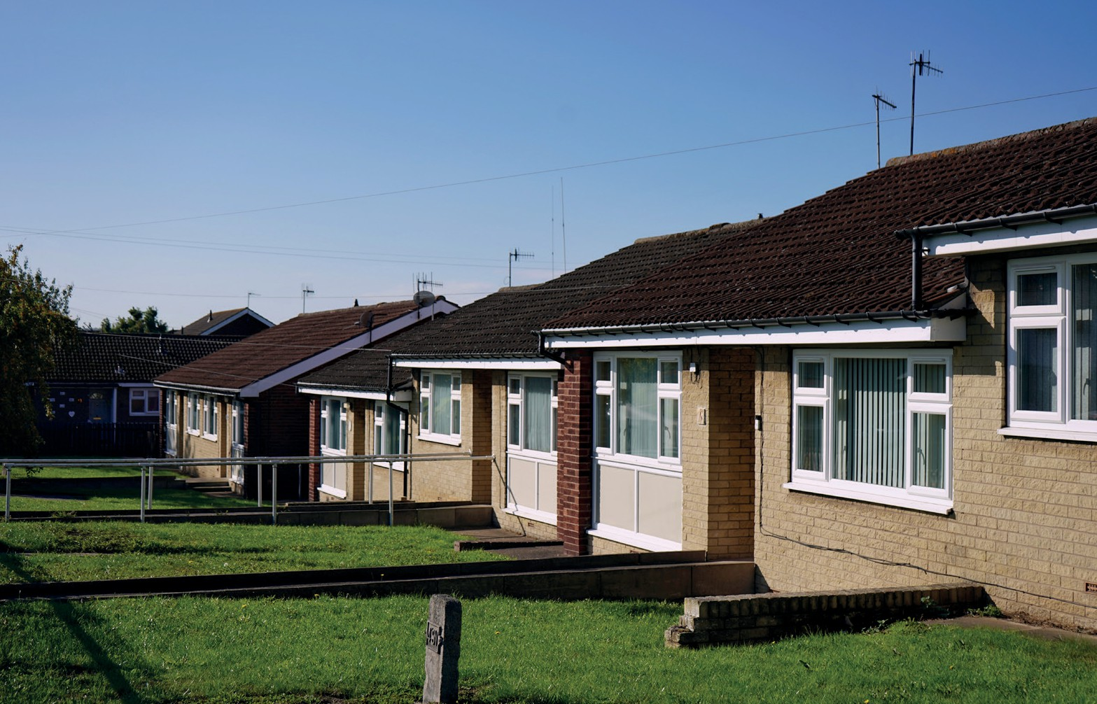
- Further reductions in the use of hotels as emergency accommodation.

Council bungalows in Parkgate

Over the next five years, we will:
  - Improve our understanding of the diverse needs of our tenants, including vulnerabilities, so we can get better at early intervention and tailoring our services.
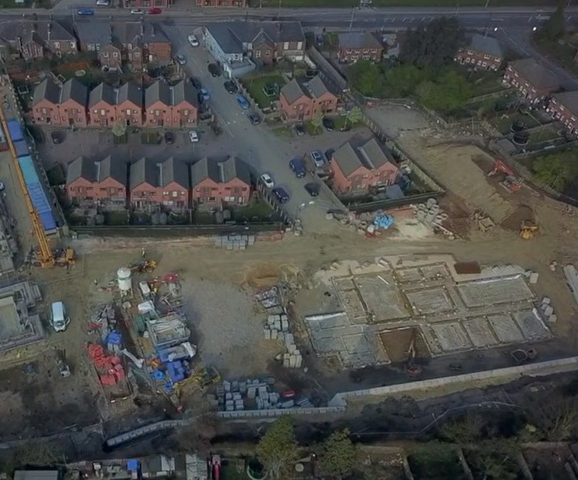
  - Continue to build and acquire a range of house types, to meet the needs of older residents, residents with disabilities, vulnerable adults and families, looked after children and care leavers to rent from the Council or housing associations. This will be informed by developing our understanding of different housing needs e.g. armed forces, learning disability and autism, physical disability, mental health, and gypsies and travellers.

Joint Adult Care and Housing development in Canklow
  - Fully implement our new approach to aids and adaptations, including stepping up the use of discretionary grants, with an aim to reduce the average length of time waiting for major adaptations.
  - Change how our social housing allocations policy works, so we are making better use of our limited Council housing stock, meeting housing need, and supporting successful and balanced communities.
  - Further strengthen our focus on homelessness prevention through an updated Homelessness Prevention and Rough Sleeper Strategy. We will step up support for those facing homelessness; we will ensure financial support is made available including issuing discretionary housing payments; and we will work more closely with families and landlords to keep people in their homes for longer.
  - Increase the provision of suitable temporary and move-on accommodation. We will improve the quality and service standards of temporary accommodation and deliver further reductions in the usage of emergency hotel accommodation. We will work with private landlords and housing associations to improve the range of permanent accommodation available.

2.7%
properties in Rotherham
are empty homes.

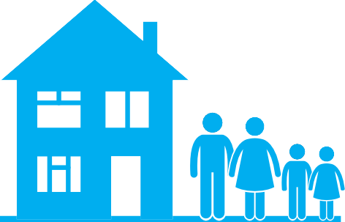
Average number of
days to relet Council homes

32 days
PRS accounts for up to 41% of
the housing market in some areas, with an increase of up to 14%
in some areas since 2001 and is becoming a significant part of the overall housing market.
Our previous three priorities focused on buildings and the needs of our residents in terms of their individual homes. It is also important to consider the wider impact of housing in communities. Our homes are the building blocks for neighbourhoods and all our residents deserve to live in safe, happy and thriving communities.
Working with community groups is important to ensure that our residents have a voice in where homes are built, holding landlords to account and influencing policy and decision making. The Council works in partnership with Rother Fed to support a range of groups that are committed to bringing communities together. Rother Fed works with Citizens Advice, Laser Credit Union and Voluntary Action Rotherham to provide ‘Open Arms’ Community Support Hubs, with the aim of empowering communities, making best use of community assets and focusing on financial and social inclusion. The Council received TPAS exemplar accreditation in 2022 for demonstrating our long-term commitment to tenant engagement.
One way to improve neighbourhoods is by addressing homes that are not currently in use. Empty homes can be used to increase the overall number of homes available to our residents, create more owner occupied, private-rented and social-rented homes and reduce blight and anti-social behaviour in our communities. Empty homes can affect local house prices and the quality
of life of neighbours. Bringing empty homes back into use was a popular choice by residents during the Housing Strategy engagement. For many, regenerating neighbourhoods including the town centre by repurposing buildings to create more homes is important.
On average, around 2.7% of Rotherham’s private housing stock is empty at any given time and while some of these properties can be considered part of

a well-functioning housing market, some properties can be problematic, especially when left empty for long periods or if they fall into disrepair. In 2022 the Council appointed an Empty Homes Officer, to offer advice and guidance to owners of empty properties and since then 76 privately owned empty properties have been brought back into use across the borough.
- Received TPAS exemplar status in recognition of the work we do to ensure our tenants are at the heart of everything we do.
- Appointed an Empty Homes Officer, bringing 76 empty homes back into use since 2022.
- Reduced the turnaround time of empty Council homes (voids) between tenancies from an average of 53.5 days to 31.83 days.
- Contributed to the Ward Housing Budget, which includes estate improvements, security upgrades, planting, and lighting, to uplift shared spaces and improve community safety.
- Generated over £10m in social value for the town centre housing developments. A further £10m in social value was achieved by Mears and Equans as part of the repairs and maintenance contract.
- Responded to 1,041 reports of anti-social behaviour across the borough.

Over the past three years we have:

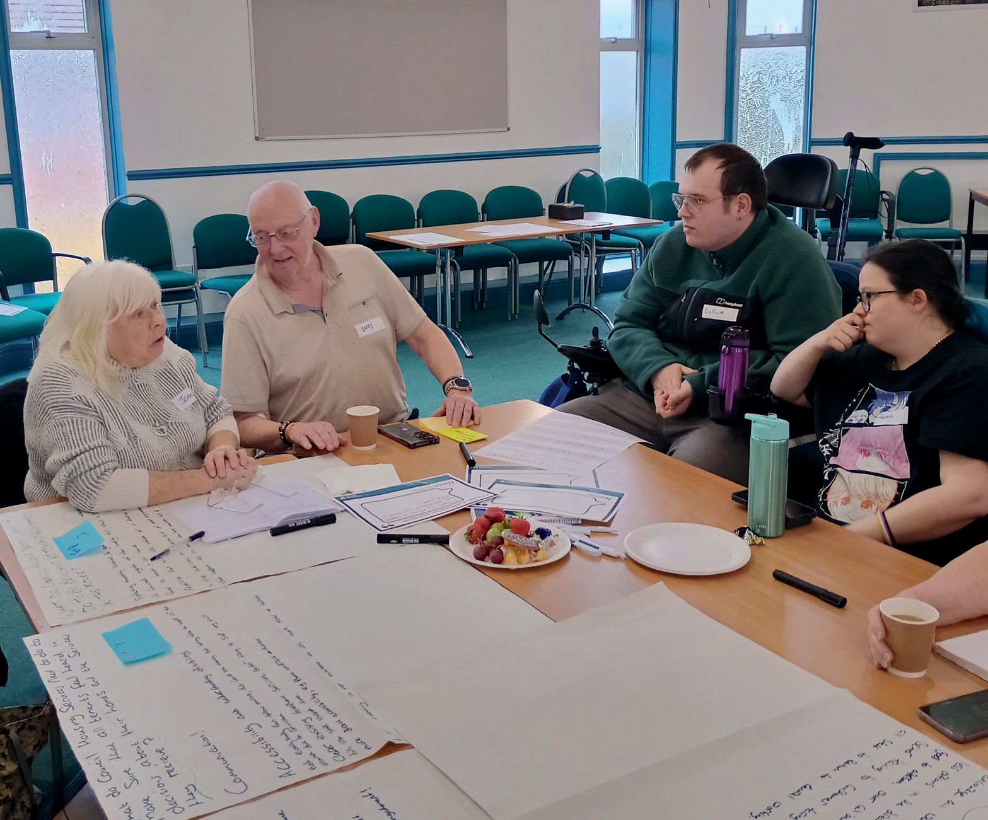

Tenant engagement at a Rotherfed session

Investing in housing can have a positive impact on neighbourhoods. Social value brought about by house building helps bring prosperity to areas through the hiring of local businesses, creating jobs and helping residents develop skills. Improvements to neighbourhoods can be made in other ways, including improving street scenes, security and lighting of neighbourhoods. Our Ward Housing Budget provides the opportunity for tenants to submit project proposals and ideas to ward councillors as to how the budget could be best spent on improvements that directly benefit Council tenants.
As part of our engagement work, a number of residents were concerned about anti-social behaviour in their neighbourhoods. Some suggestions from our residents included regular visits and tenant checks and enforcing sanctions on those having a negative impact on the neighbourhood. Our multi-agency approach working with community groups and organisations will continue to ensure that anti-social behaviour is managed effectively.
In some areas of the borough the significant increase in the private rented sector, high rates of empty properties (10% in some areas) and short-term transient tenancies are having a negative impact on those communities.
Subject to consultation, Selective Licensing areas will continue to help deal with anti-social behaviour in the private rented sector and therefore contribute to ensuring that neighbourhoods are safe.
It is important that we identify neighbourhoods in the borough where improvements to housing and the local environment can play a role to help solve significant local issues and address deprivation. For example, the Council is working with residents at the Little London estate in Maltby to deliver
on a Council commitment to address two derelict buildings. The Council is exploring what more can be done to regenerate areas like these should national funding opportunities become available.

Our Aims:
- We will bring empty homes back into use.
- We will invest in our communities to ensure they are inclusive and safe.
- We will ensure that new and improved homes support regeneration.

How we will measure success:
- Reduce the number of long-term empty homes.
- Increase the percentage of Council tenants satisfied we make a positive contribution to neighbourhoods.
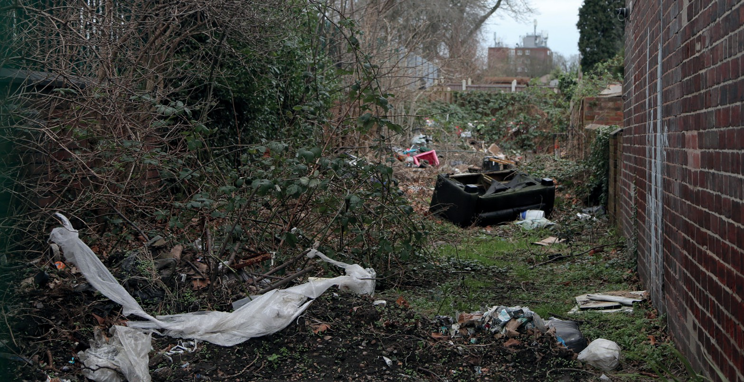
- Increase the percentage of tenants satisfied with our approach to handling anti-social behaviour.

Example of fly-tipping

To achieve these measures over the next five years, we will:
  - Deliver our Empty Homes Plan. We will provide advice to owners and landlords of empty homes to help bring homes back into use, use enforcement powers to tackle empty homes where necessary, and ensure that empty Council homes (voids) are brought back into use as soon as possible.
  - Continue to invest in and improve our tenant and resident engagement, including through creating a new Tenant Engagement Framework with our Council tenants; working to retain our TPAS exemplar status for demonstrating long-term commitment to community engagement; and working with Rother Fed and our tenants to strengthen tenant voice and influence.
  - Deliver improvements to our council estate communal and shared areas, through introducing new estate caretaking teams and increasing our investment in environmental schemes around our housing blocks.
  - Improve our approach to tackling anti-social behaviour in our communities, including by making more use of enforcement powers such as civil penalty notices, finding new purposes for areas of land currently attracting anti-social behaviour and fly-tipping, and strengthening the approach our housing officers take when dealing with incidents.
  - Make £216,000 in funding available annually to be allocated to projects and environmental improvements that directly benefit council tenants via our Ward Housing Budget.
  - Implement the Council’s Banning Order Policy to tackle landlords who are in breach of one or more of the sections of the Housing Act 2004.
“There are lots of derelict/dilapidated buildings in the borough. These could be used for affordable homes/flats for local people.”
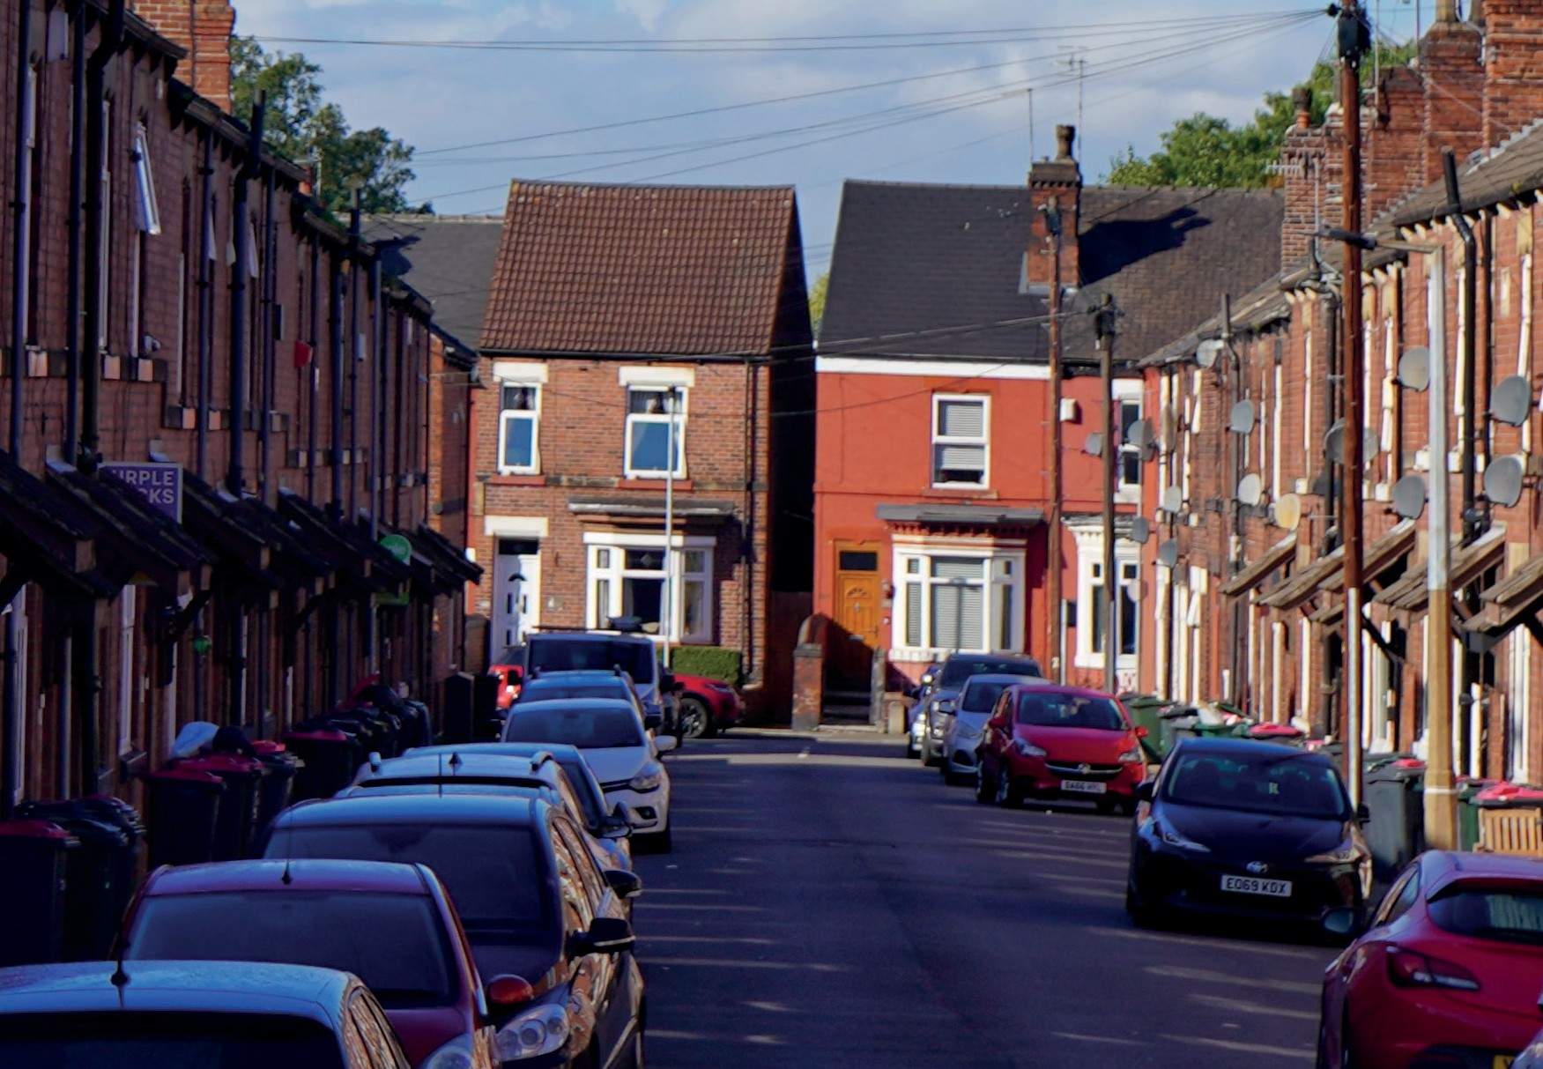
“Consider ways of leasing empty private sector properties that could be offered as affordable rented accommodation through an ethical lettings process.”
Parkgate Selective Licensing Area

Building new Council homes for rent in East Herringthorpe
The development is forward looking, having been designed to achieve the “Future Homes Standard” which is due to be implemented in 2025. This means that the homes are highly energy efficient and exceed the specification of anything previously built by the Council, acting as a demonstrator and trial of new and emerging technologies for the forward Programme:
- The first ‘no gas’ development utilising Air-Source Heat Pumps (ASHP) – ensures the homes are ‘zero carbon ready’ for when the national grid is fully decarbonised.
- Under-floor heating – improves the efficiency of the ASHP system and internal space standards on the ground floor.
- Integrated solar photo-voltaic panels (PV) – reduces carbon emissions by allowing the homes to self-generate energy and helping reduce energy bills for occupiers.
- Mechanical ventilation and heat recovery (MVHR) – improves the efficiency of the ASHP system by allowing air to be recirculated within the dwelling. MVHR can also improve internal air quality, reduce condensation, and help to manage over-heating.
- Enhanced airtightness works – reduces heat loss.
Best Affordable Housing Development (Up To £5M): Northern Housing Award 2025
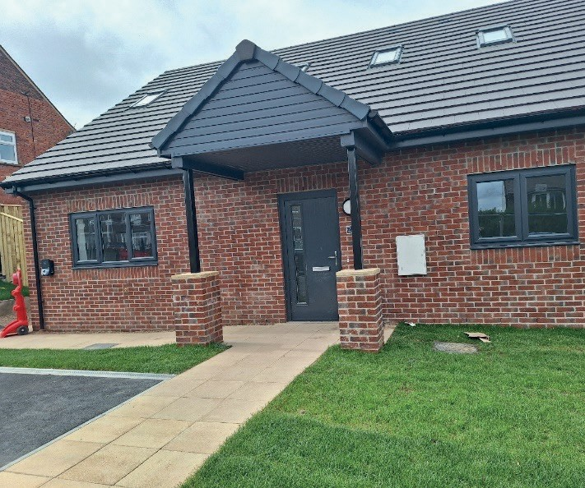
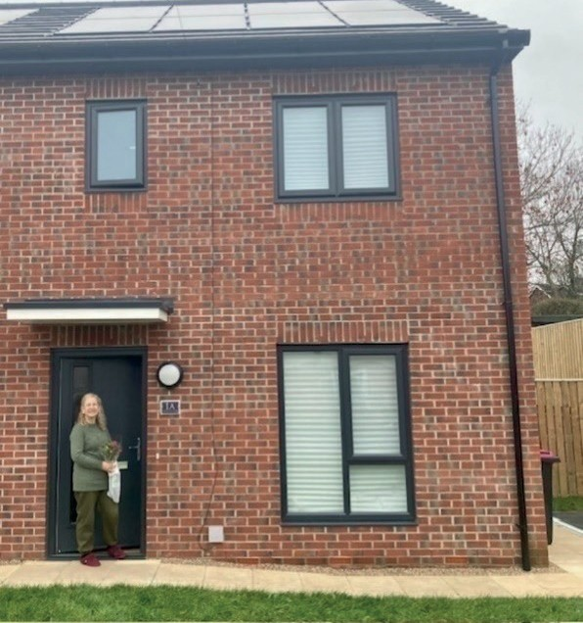

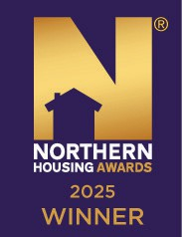
In April 2024, the Council completed an award-winning scheme delivering ten homes on sites in East Herringthorpe. These ten homes include family-sized homes, bungalows, our first one-bedroomed homes (to help address the significant need for smaller homes, whilst providing a different offer to flats) and the first four-bedroomed ‘dormer’ style wheelchair user dwelling (disabled persons unit), designed to support families with one or more individuals with acute health needs, whilst having a smaller ‘footprint’ than a traditional four-bedroomed bungalow.

Feedback from tenants has been very positive, including:
In line with the Council’s Social Value Policy, the main contractor, which was from West Yorkshire, had a target to spend £100,000 with local suppliers. They actually spent £145,000.
Huws Gray supplied the bricks and mortar, TKL provided the skips, there was concrete from Cemex, paint from Akzo Nobel, Howdens did the kitchens, and, finally, Demex dealt with demolition and asbestos removal.

“Improved my life straight away, no stairs to manage now as I’m all on one level, improved health as I don’t struggle with my breathing as much, able to manage bathing much better with my new shower instead of a bath.”
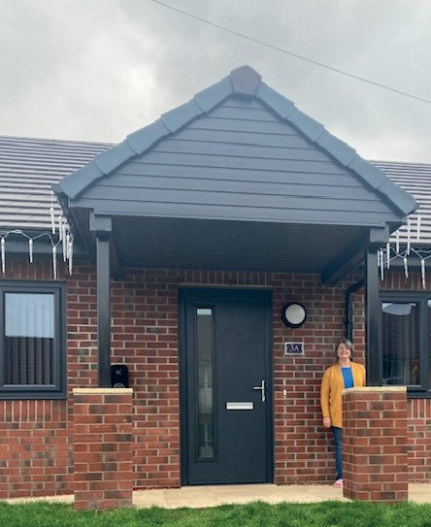
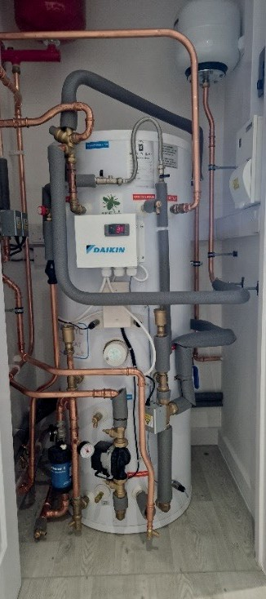
“Much cheaper as there is no gas and we are just paying for electric, seems a warmer property and more energy efficient, it’s perfect for us, I can’t fault it”
“This property has made a massive difference to my life, I can move round freely and it has given me my independence and dignity back. This has had a knock-on effect to improving my teenagers lives too and allowed them to be kids rather than worrying about me all the time. I’m able to have visitors round where I don’t feel embarrassed anymore.”

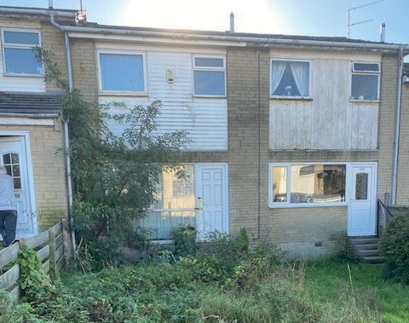
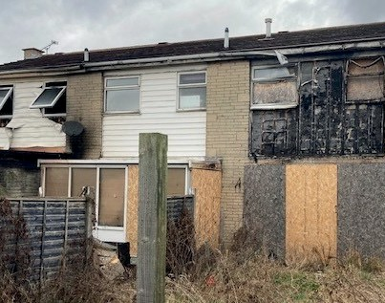
Bringing empty homes back into use

Before

Before

Strauss Crescent, Maltby
- One of the properties pictured was reported as being empty in 2021, which resulted in a visit that led to identifying that a further two properties were empty. The three properties had been empty since 2018, due to fire damage, caused by arson.
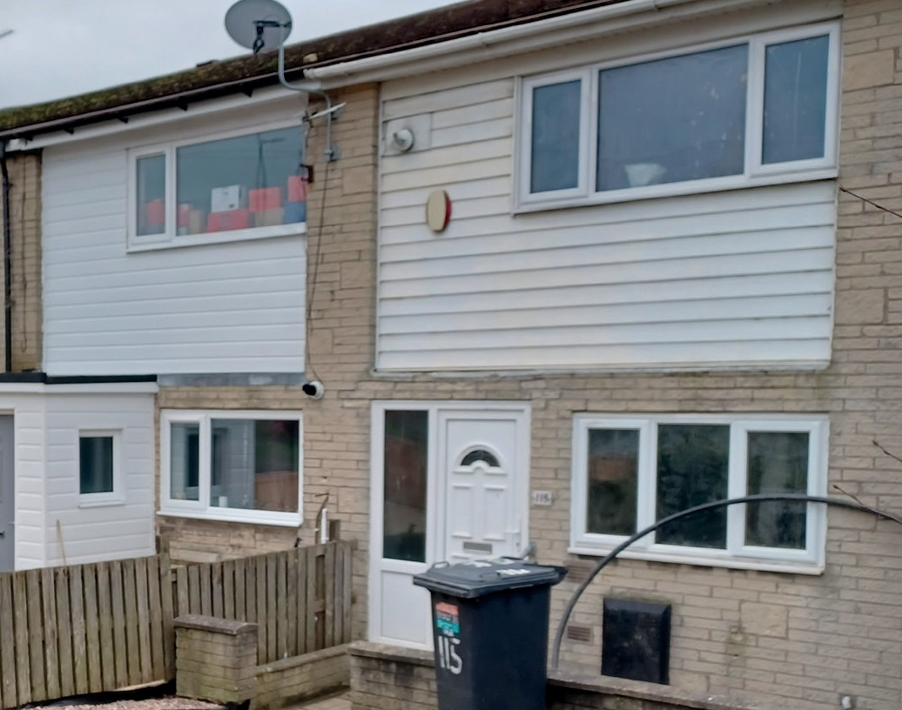
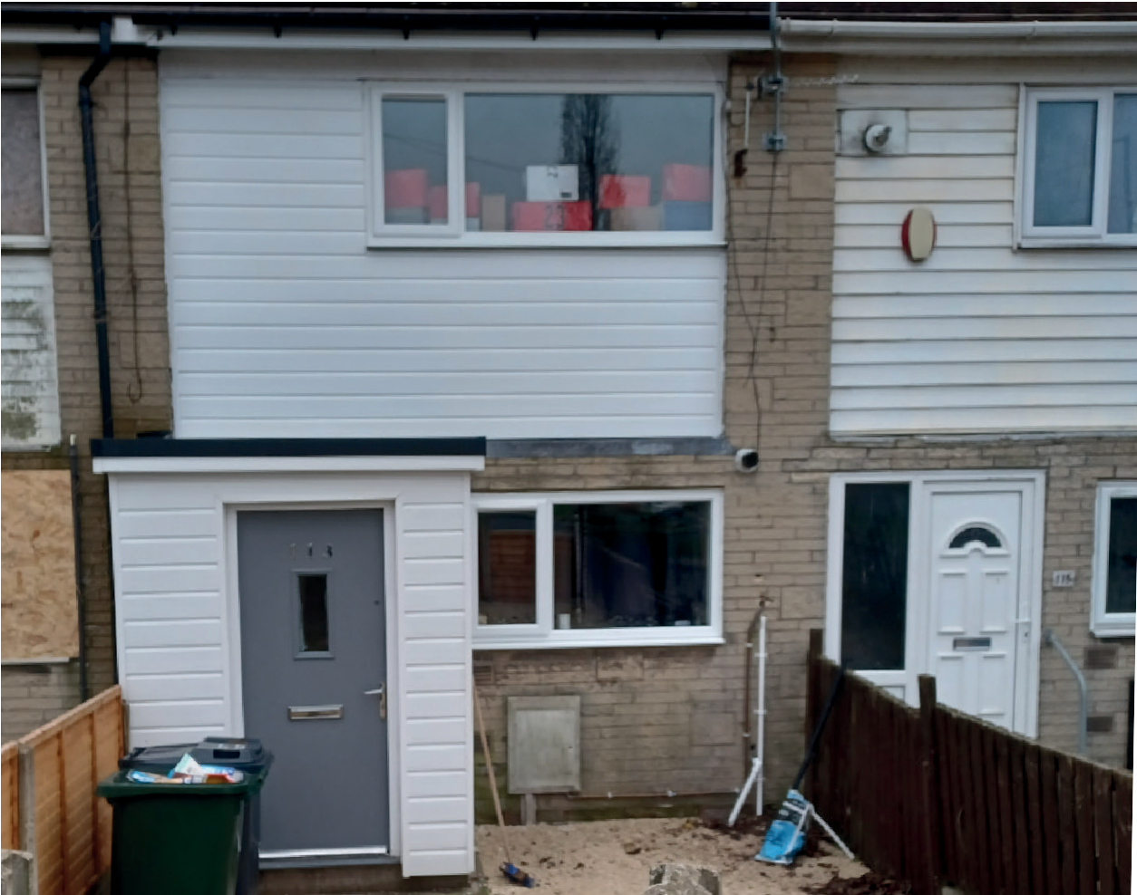
- A combined approach of assistance and enforcement resulted in all three properties being sold at auction.

After

After
- Two properties have been extensively refurbished and occupied in 2023 with the original empty property remaining empty. Engagement with the ‘new’ owner is underway.

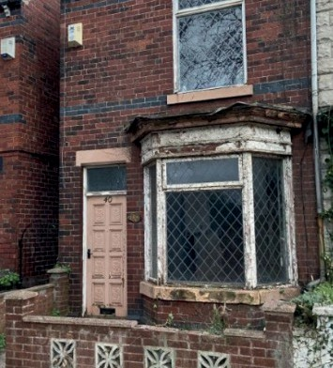
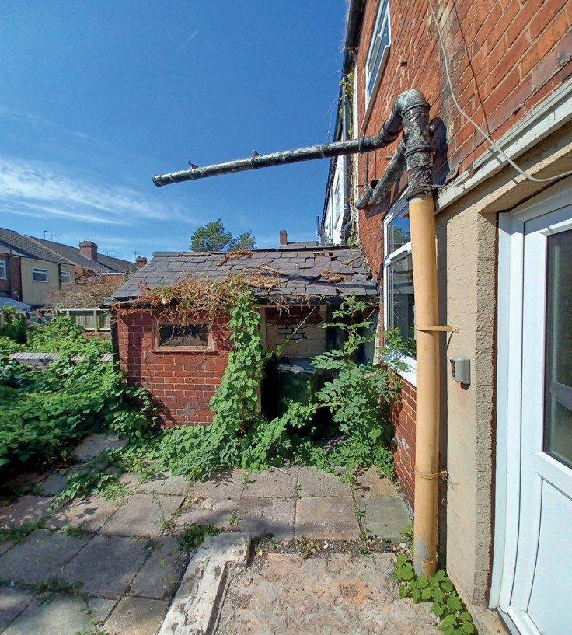
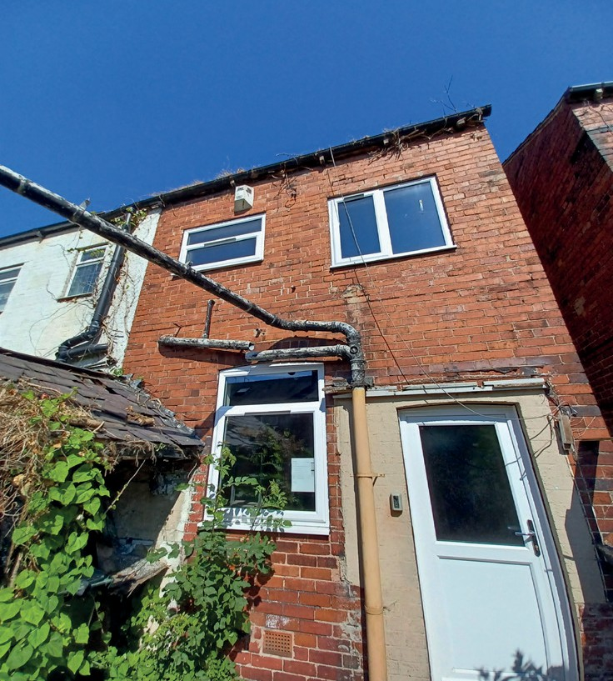
Bringing empty homes back into use

Before

Before

Before

Cambridge Street, Clifton
- This property has been empty since 2018.
- The property was reported empty in 2022, in a dilapidated condition, and causing a blight to neighbouring properties.
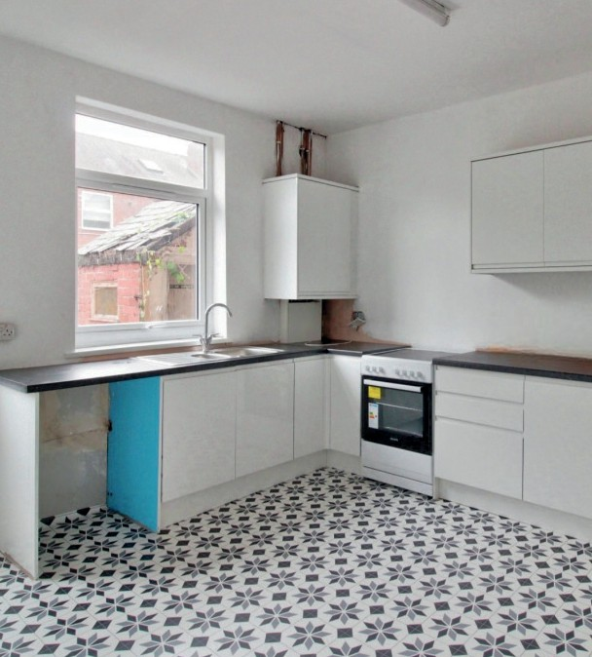
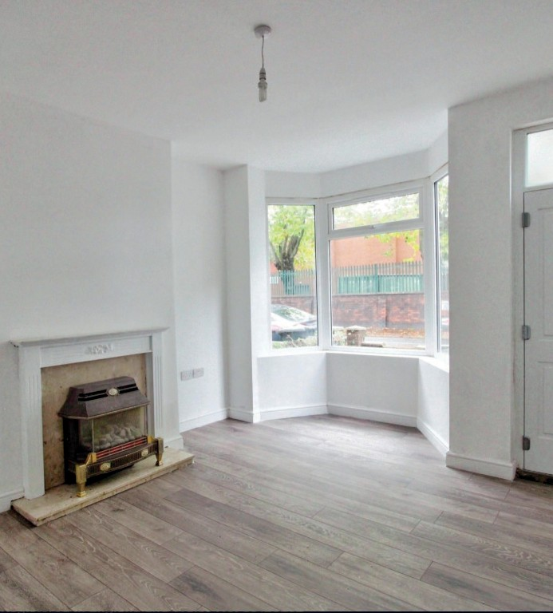
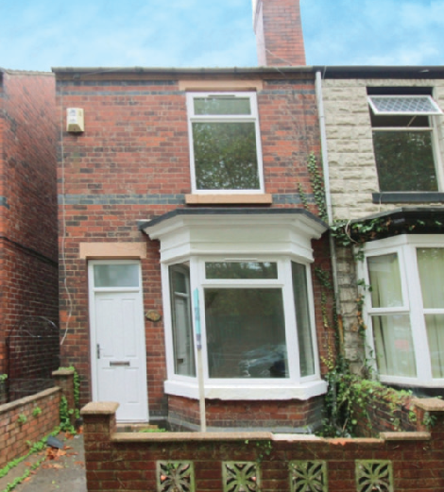
- The owner of the property had passed away so the Council appointed Fraser and Fraser, probate researchers, to trace and engage with the owner’s family members.

After

After

After
- The property was sold at auction, 22% above guide price. It was then re-sold, for a 9% profit, and refurbished during 2022/23.

Preventing homelessness
In 2023-24, around 9% of homelessness cases in Rotherham were due to non-violent relationship breakdowns. Relationship breakdowns can have a significant impact on mental health, as well as considerably reducing income and it can become difficult to meet the costs of running a home.
Martin experienced a significant relationship breakdown with his partner, which led him to begin sofa surfing among friends. After several months of navigating this precarious living situation, he had exhausted all available options and sought assistance from the Council.
In recognition of his health conditions, the Council provided Martin with temporary accommodation in a hotel while they worked to secure a more permanent solution. Subsequently, he was offered a self-contained flat in the private rented sector, marking a pivotal moment in his journey towards stability.
Given that Martin had not maintained a tenancy for several years, the Council recognised the need for additional support during this transition. To facilitate a smooth adjustment, the Council implemented the Action Housing Floating Support service, which was commissioned specifically for this purpose.
This service proved invaluable, providing Martin with the necessary assistance to establish his new living arrangements. They worked closely with him to ensure that all of his bills were set up and paid promptly, thereby fostering a sense of security and independence as he settled into his new home.

Supporting our residents to live independently
Two permanent wheelchair using residents, living independently of one another wanted a home to live together in. The couple were assessed by our occupational therapy team after a referral from Keychoices. They were awarded medical priority on the housing register for a large two-bedroomed or a three-bedroomed bungalow, with level access, widened internal and
external doorways and hallways and sufficient turning space in all necessary rooms. One of the Council’s recently built two-bedroomed bungalows, which was partly designed with input from the occupational therapy team, became available and the couple were successful when bidding for the home.
The bungalow is wheelchair accessible internally and externally, with a driveway large enough for two vehicles, an accessible garden, level access shower and wide internal hallways and doorways. Accessible bungalows are built to a standard design, so that they are available to as large a number of residents as possible. However, the only adaptation that needed to be made to this bungalow to meet the needs of the couple was to install a ceiling track hoist for their bedroom and bathroom.
The couple can now physically live comfortably in their new home along with an increase in wellbeing; they now feel like a ‘proper couple’ who live together. Living together has also reduced their care package requirements, needing only one night carer, and the two homes that the couple previously lived in were made available to other wheelchair users in need of a suitable home.

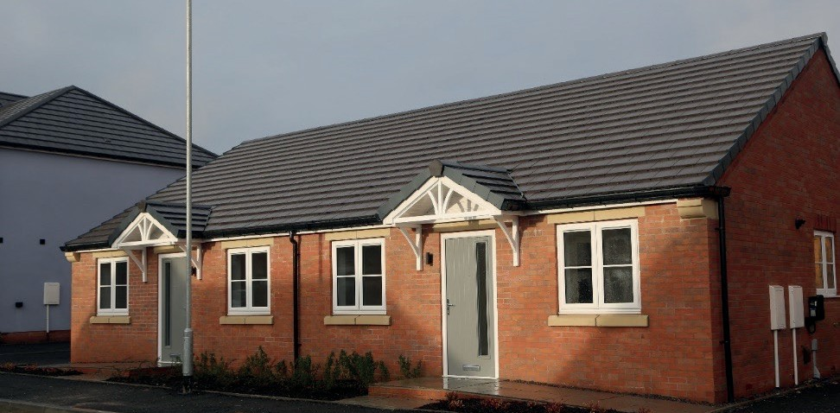

Enabling housing development at Eldertree Lodge
A former pig farm known as Eldertree Lodge in Thorpe Hesley was earmarked for residential development in the Council’s Local Plan. CADAM Construction Ltd, a local SME builder, secured planning permission to build 24 new homes on the Eldertree Lodge site, however a Council garage site prevented an entrance to the site. The Council worked with CADAM to sell the site in 2021 to enable the new housing site.
Following consultation with residents, tenants that had a garage on this site were moved to a nearby garage site, providing full occupancy at the nearby garage site.
The Council were able to acquire two bungalows for over 60s as part of the Section 106 planning agreement to deliver affordable housing on large development sites and the tenants moved in in early 2024.
The Council remains committed to working with local small and medium-sized developers to deliver much needed high-quality and affordable homes.
Caroline spoke of her delight after recently moving into one of the new bungalows with her husband Terence: “I can’t tell you how happy we are with our new home, it’s absolutely beautiful.
“The quality of the build and the fixtures and fittings are extremely high, you’d have thought we’d have paid a small fortune for it. We feel incredibly lucky and we’re really looking forward to making it our home.”
Cain Green, Group Development Director at Cadam Construction, said: “It has been a pleasure to work with Rotherham Council and we look forward to continuing this relationship.
“Our team dedicates themselves to delivering the highest quality work and we are proud that these bungalows can assist the Council in its goal of providing affordable housing for residents across the borough.”
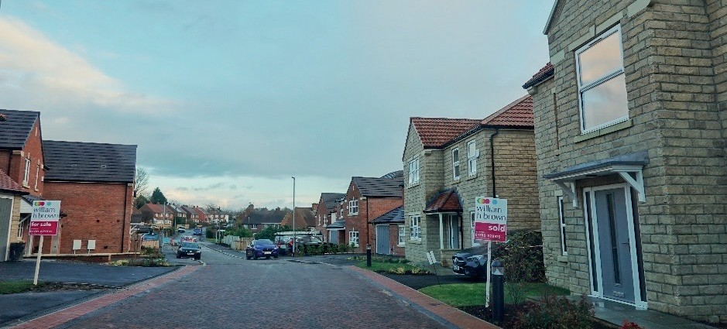

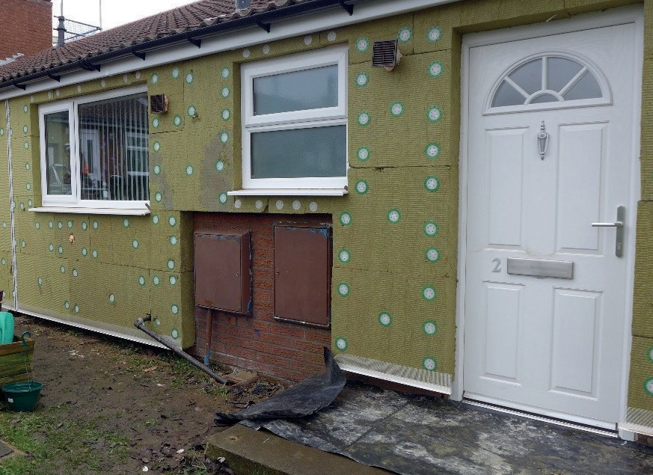
Decarbonisation of Council homes in Maltby
The Maltby area was identified as a key area that would benefit from thermal improvements alongside planned works to Council homes. 130 homes were selected for investment, based on health and deprivation levels in the area. The Council engaged Parity Projects to carry out carbon assessments on Council homes to provide comprehensive insight into what measures are required to achieve net-zero carbon.
The Council worked with its partner Equans to install thermal improvements including external wall insulation, cavity wall insulation, loft insulation and high performing windows and doors. Some homes also received new roofs. Works were carried out with as little disruption as possible to our tenants.
The works supported around 70 jobs and received high customer satisfaction.
The average annual energy bill of homes where works have been completed was reduced by £426. This was significantly more than initial estimates, due mainly to the rise in energy prices.
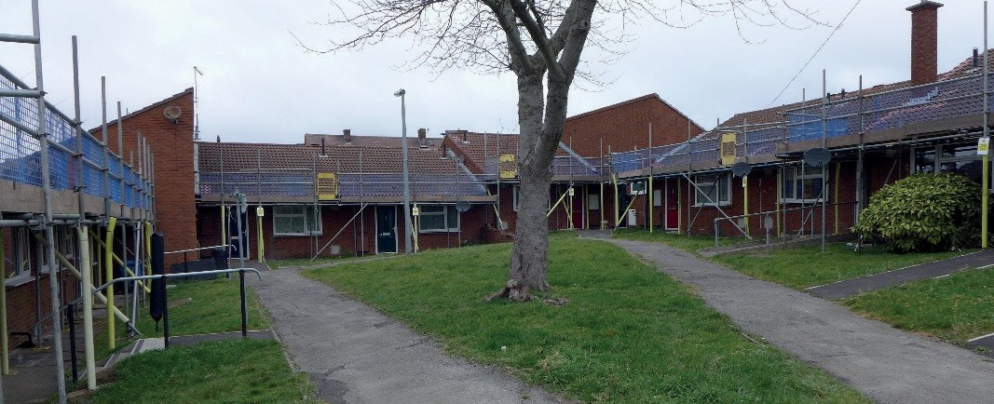
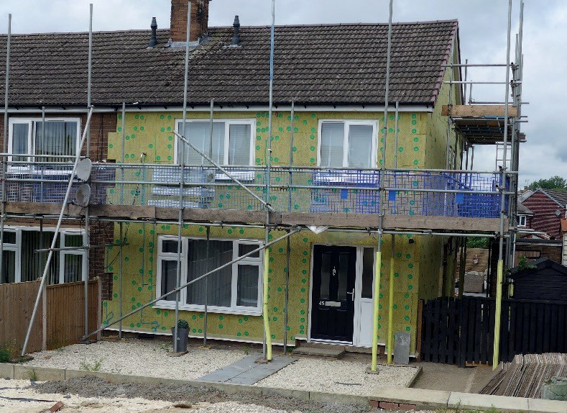


Preventing fraud
The Council takes fraud very seriously and have an officer to help prevent housing tenancy fraud and benefit fraud.
One tenant, in a Council home since 2016 submitted a Right to Buy application to buy their Council house in 2023, stating on the application that the Council property was her main and only home.
The Council’s Housing Estates team carry out regular tenancy health checks by visiting properties, and the tenant stated that they were living in the property with their two children. A neighbour then reported that the
tenant was not living at the property and a letter was sent, with the tenant responding saying that they were still living at the property.
The tenant was then interviewed under caution with a solicitor. In a pre-prepared statement, the tenant stated that they had not been using the tenancy as they should on health grounds and that they were happy to hand the property back to the Council and cancel the Right to Buy application for the property. At the end of the interview, the tenant and solicitor were given time to complete the termination notice returning the property and the keys were handed back shortly after. This case also uncovered benefit fraud, in the form of single person discount on Council tax, housing benefit and universal credit fraud.
The Council prevented the sale of the property through the Right to Buy scheme, thus retaining much needed Council housing and was let to another resident on the housing register.

Anti-social behaviour
Our housing officers undergo comprehensive training to effectively deal with Anti-Social Behaviour (ASB).
This training ensures that they:
- Identify and understand ASB issues
- Know when and how to report incidents
- Are aware of the powers available to the Council to address ASB.
Equipped with this knowledge, our officers can take prompt and effective action to tackle ASB, providing a safer and more supportive environment for our community.
What was the issue: The Council received reports of drug related criminal activity being perpetrated at a Council tenancy. This activity included drugs possession/dealing, noise nuisance and disturbance to neighbours.
What were the challenges: Gathering evidence needed to be handled sensitively and with the wishes of complainants in mind, who were fearful of reprisals. There was organised crime group activity within the area and action needed to be taken in that context.
What did we do, who did we involve: The Council worked with the local Police team and partners agencies to address the issue. The perpetrator was subsequently charged with a serious criminal offence and given a custodial sentence. Due to the conviction, the Council was able to take action to recover possession of the tenancy on mandatory grounds for possession. The tenant was advised of the action to be taken and subsequently decided to voluntarily end his tenancy.
What outcome was achieved: The Council obtained possession of the tenancy and will now look to relet the property on a sensitive let, mindful of the situation that local residents have previously endured. The Council, Police and partners continue to work to disrupt and address organised crime and ASB within the locality.

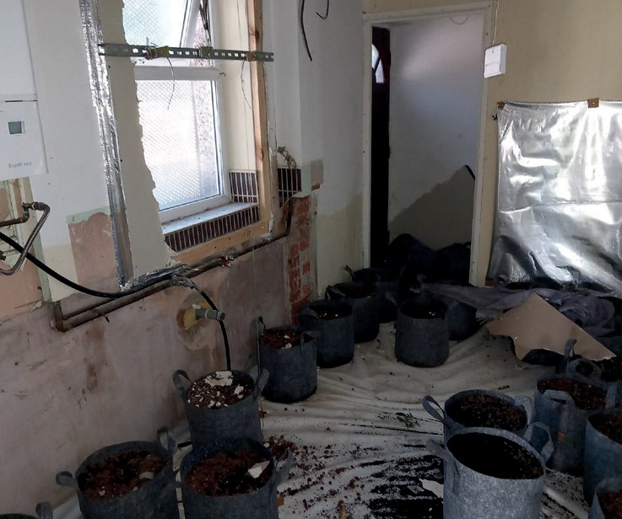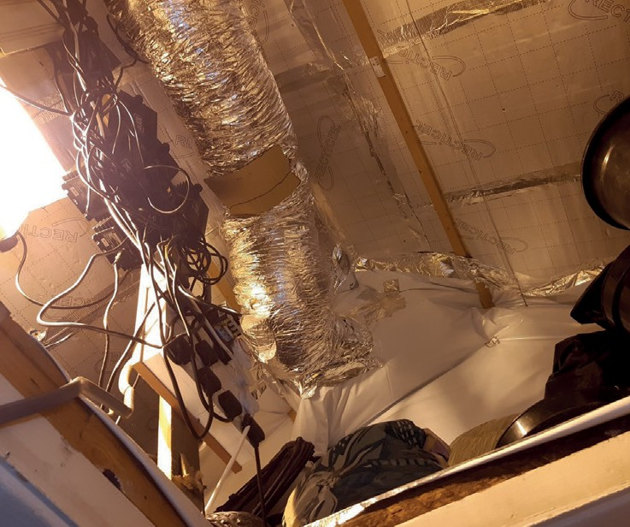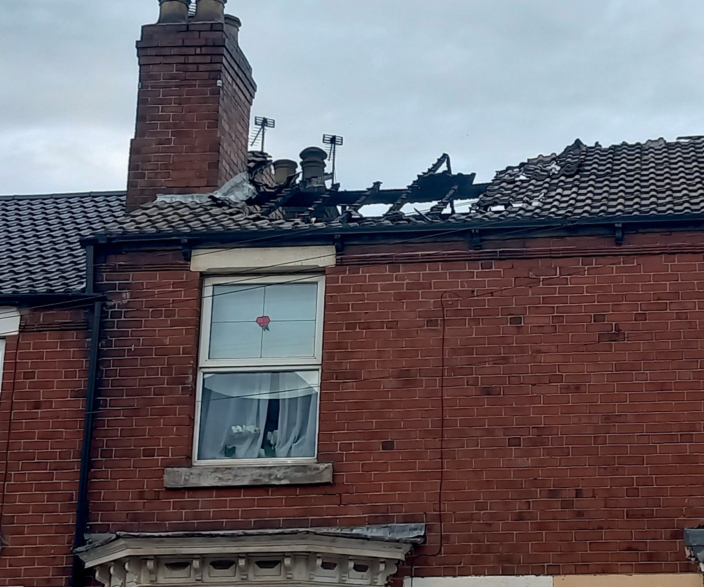

- The Housing Strategy has been developed with residents and partners feedback and has been approved by Cabinet. The Improving Places Select Commission will receive annual reports and provide scrutiny and challenge, to ensure that we are focusing on and monitoring the right outcomes. When the Strategy is refreshed, we will follow the same engagement and consultation process.

GOVERNANCE, ASSURANCE AND DELIVERY
- The Rotherham Strategic Housing Forum meets bi-monthly and members include representatives from housing associations, developers, health services and voluntary and community organisations, and this group
will also play an important role in overseeing progress against the Housing Strategy.
  - Additionally, the service that the Council provides to tenants is governed by the Consumer Standards set by the Regulator of Social Housing. An inspection of our service will take place during the Housing Strategy period. Our partnership with tenants is central to our meeting the Standards and our ambition is
to re-achieve our TPAS tenant engagement exemplar status during 2026.



46 ROTHERHAM’S HOUSING STR AT EGY 2025-2030

Ref: 88672 / November 2025

